**IMAGE BASED CROP DISEASE DETECTION USING CONVOLUTION NEURAL NETWORKS ALGORITHM**

**Abhiti Labroo(1) , Kunika Sharma(2),**

**Dr.Aman Sharma (3)**

1. Ug student, CSE, JUIT,Waknaghat
2. Ug student, CSE, JUIT,Waknaghat
3. Assistant Professor, JUIT, Waknaghat

TABLE OF CONTENTS

1.Abstract

2. Main contents of the project.

2.1 Introduction

2.2 Literature Survey

3. Background and Preliminaries

3.1 Deep learning algorithm: Using CNN

4.Results and Discussions

4.1 Information regarding the dataset.

4.2 Implementation details of the project

4.3 Results and Output

4.4 Comparison with the existing model.

5. Conclusion and Future work

6. References

**ABSTRACT**

Crop Diseases can be detected by leveraging the power of Deep Learning. Using Deep Learning Models to detect and classify the disease of plants and guide the farmers through the videos and give them instant remedies to overcome the loss the crops and fields. Plant disease detection is an interesting field in India. Plants are the way to live. We are completely dependent on plants from our daily life factors to breathing. So, there should be proper care of plants.

Our contribution in formulating the project is to provide the farmers and the agricultural enthusiasts with an accurate and a fast way so they can either save their crop or agricultural yield on time and learn more the diseases ,symptoms and their treatment so goes on waste. It would definitely contribute in the waste management in the longer run.

Many studies show that quality of agricultural products may be reduced due to various factors. The plant diseases are such as fungi, bacteria, and viruses. The leaf diseases not only restrict the growth of the plant but also destroy its crop. There is the need of some expert to identify plant diseases but manual identification is time consuming. So, some automatic methods required.

The conclusion of this project is to provide more knowledge of the actual science that goes behind in growing the crops via modern ways and method.

**Keywords**: Deep Learning, Image Processing, Leaf Disease, Feature Extraction, Disease Identification.

**MAIN CONTENTS OF THE PROJECT**

**INTRODUCTION**

Plant disease diagnosis is an art as well as science. The diagnostic process (i.e. recognition of symptoms and signs), is inherently visual and requires intuitive

judgement as well as the use of scientific methods. India is a cultivated country and about 70% of the population depends on agriculture. Disease on plant leads to the

significant reduction in both the quality and quantity of agricultural products. The studies of plant disease refer to the studies of visually observable patterns on the plants. Monitoring of disease on plant plays an important role in successful cultivation of crops in the farm. In early days, the monitoring and analysis of plant diseases were done manually by the expertise person in that field. This requires large amount of work and also requires excessive processing time. The image processing techniques can be used in the plant disease detection. The detection and classification of leaf diseases accurately is the key to prevent the agriculture loss. Different plant leaf bears different diseases.

The basic concept of leaf symptoms and diseases are Leaves are mainly affected by bacteria, fungal and viral. A symptom of plant disease is a visible effect of disease on the plant. Symptoms may include a detectable change in color, shape or function of the plant as it responds to the pathogen. Here, we are discussing these diseases symptoms that should be keep in mind if plant growth seems low.

**Viral Disease Symptoms**

Among all plant leaf diseases, those caused by viruses are the most difficult to diagnosis. Viruses produce no telltale signs that can be readily observed and often confused with

nutrient deficiencies and herbicide injury. Aphids, leafhoppers, whiteflies and cucumber beetles insects are common carriers of this disease, e.g. Mosaic virus, and

look for yellow or green stripes or spots on foliage, Leaves might be wrinkled, curled and growth may be stunted.

**Bacterial Disease Symptoms**

Pathogenic bacteria cause many serious diseases of vegetables. They do not penetrate directly into plant tissue but need to enter through wounds or natural plant openings. Wounds can result from damage by insects, other pathogens, and tools during operations such as pruning and picking The disease is characterized by tiny pale green spots which soon come into view as water- soaked.

**Fungal Disease Symptoms**

Plant leaf diseases, those caused by fungus are discussed below .Late blight caused by

fungus. It first appears on lower, older leaves like gray-green spots, water- soaked. When fungal disease matures, these spots darken and then white fungal growth forms on

the undersides.

Plant leaf disease detection includes some basic step of image processing to detect & classify plant leaf disease. These steps are image acquisition, image pre-processing,

image segmentation, feature extraction, classification and leaf disease detection.

Some of the basic concepts of Plant Disease Detection are:

**Image Acquisition** - The first stage of any vision system is the image acquisition. Image acquisition involves the steps to obtain the plant leaf and captured the high quality images through the camera. Images are acquired from the internet or agriculture field. The efficiency of the concept depends upon the quality of database images. This image is in RGB (Red, Green, and Blue) form.

**Image Pre-Processing**- Image pre-processing involves the steps of image enhancement, RGB to Lab conversion, filtering etc. Here, image enhancement is carried out for increasing the contrast. Image smoothing is done using the filtering techniques. There are different types of filtering techniques available in image processing like median filter, average filter, Gaussian filter etc.

**Image Segmentation-** Image segmentation means partitioning of image into various parts of same features or having some similarity. The segmentation can be done using various methods like otsu’ method, k-means clustering, converting RGB image ,into HIS model etc. The K-means clustering is used for classification of object based on a set of features into K number of classes. The classification of object is done by minimizing the sum of the squares of the distance between the object and the corresponding cluster.

**Feature Extraction-** Feature extraction plays an important role for identification of an object. After performing the image segmentation the disease portion from the image is extracted. In many application of image processing feature extraction is used. Color, texture, shape, edges, morphology are the features which can be used in plant disease detection. Color features are extracted by various methods, such as Color histogram, Color moments and Color structure descriptor.

**Classification & Detection of Diseases-** Finally, classifiers are used for the training and testing of the datasets. These classifiers may be support vector machine (SVM), k-nearest neighbor, neural network, fuzzy logic based etc. These methods are used to classify and detect the leaf diseases.

**LITERATURE SURVEY**

**1.Khirade et al**. has discussed some segmentation and feature extraction algorithms that can be used for the detection of plant diseases by using the image of their leaves. It is very difficult to detect the plant diseases manually due to requirement of excessive time, knowledge of plant diseases and much amount of work. The author has divided the entire process of plant leaf diseases detection into five steps: Image acquisition, Pre-processing, segmentation, feature extraction and final classification of diseases. Image acquisition used the transformation structure for RGB leaf image. Then image is pre-processed to remove the noise and enhance the image contrast. Segmentation is done for the partitioning of image into various feature parts using k-means clustering, otsu filters etc. This segmented image is further used for feature extraction and then final classification is performed using various classification techniques. In this way, plant diseases can be efficiently identified.

**2.Sannakki et al**. has used feed forward back propagation Neural Network based technique for the diagnosis and classification of diseases in grape leaf. Author has used the image s of grape leaf with complex background for the diagnosis as input. Further anisotropic diffusion is used to remove the noise of the image which is further segmented using k-means clustering. Finally results are observed using neural network. Results are experimented on downy mildew and powdery mildew images with simulation in MATLAB. Confusion matrix is considered with the true positive and false positive parameters for the validation of results. The author claimed to have the training accuracy of 100% if used hue feature alone.

**3.Kutty et al.** has used the neural network based system to classify the watermelon leaf diseases of Downey Mildew and Anthracnose. Author has calculated the true positive rate, true negative rate and overall accuracy for the efficiency of the proposed concept This classification is based on the color feature extraction from RGB color model which is obtained from the identified pixels in the region of interest.. The overall performance is depicted with ROC curve having AUC value of 0.5. The true classification result also depicts the value of 75.9%.

**4.Rothe et al.** has proposed pattern recognition techniques for the detection and classification of cotton leaf diseases of Alternarnia, Myrothecium and Bacterial Blight. The dataset images are taken from the field of Central Institute of Cotton Research Nagpur. Active contour based segmentation algorithm is used for the isolation of diseased spots. Author has also suggested some feature directions to the similar concept for the crops of wheat, orange, citrus and maize etc.

|  |  |  |
| --- | --- | --- |
| Author Name | Techniques | Description |
| Sachin D. Khirade, A.B. Patil | K-means clustering | Discussed various plant leaf diseases & classification  method |
| Sannakki et al. | Feed Forward Back  Propagation Neural network | Discussed various plant leaf diseases & classification  Method. |
| Kutty et al. | Neural Network | Neural network is used to classify watermelon leaf  disease with accuracy 75.9% |
| P.R. Rothe, R.V.  Kshiragar | Neuro-Fuzzy Inference System | Cotton leaf diseases of  Alternarnia, Myrothecium and Bacterial are detected |

**Table 1.Comaprison of Different Techniques**

**BACKGROUND AND PRELIMINARIES**

**DEEP LEARNING ALGORITHM : USING CNN**

**CNN, ( CONVULATIONAL NEURAL NETWORKS)** is widely used in applications of image and video recognition and also in recommender systems and Natural Language Processing(NLP). However, **convolutional**is**more** efficient because it reduces the number of parameters which makes different from other deep learning models.

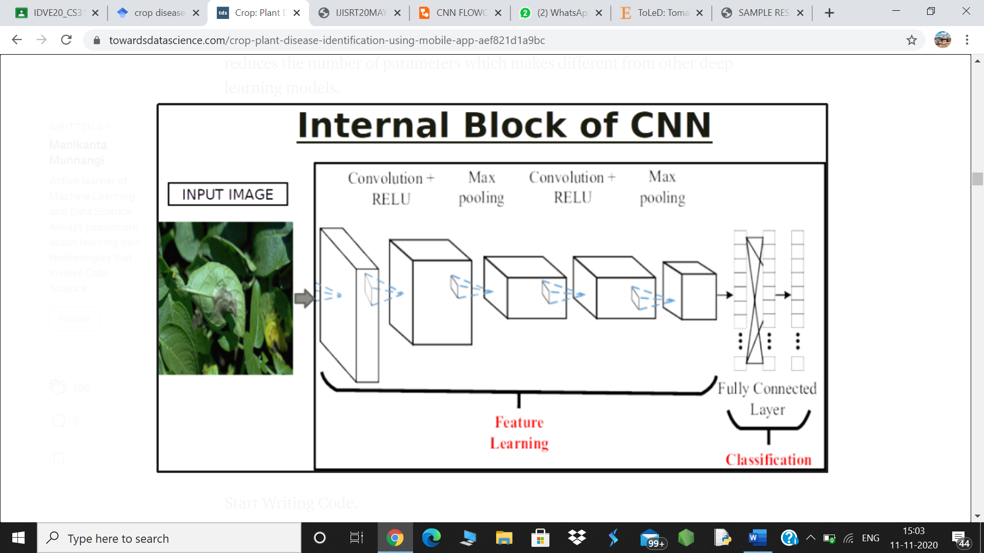

**Illustration1. CNN Internal Block**

**Main Steps to build a CNN (or) Conv net:**

1. **Convolution Layer**- CNNs are a classification of Neural Networks that have demonstrated extremely viable in zones. For example, image recognition and classification. CNNs are a sort of feed-forward neural networks produced using numerous layers. CNNs comprise of filters or kernels or neurons that have learnable loads or parameters and inclinations. Each filter takes a few input parts, performs convolution and alternatively follows it.

2.**ReLU Layer (Rectified Linear Unit) :** ReLU stands for the Rectified Linear Unit for a non-linear operation. The output is **ƒ(x) = max(0,x).**we use this because to introduce the non-linearity to CNN.

3. **Pooling Layer (Max Pooling) :** Pooling layer lessens the dimensionality of every activation map yet keeps on having the most significant data. The input pictures are partitioned into a lot of non-covering square shapes. Every region is down-inspected by a non-linear operation like average or maximum. This layer accomplishes better speculation, quicker assembly, powerful to interpretation and distortion and is commonly put between convolutional layers.

4. **Flattening :** we flatten our entire matrix into a vector like a vertical one. so, that it will be passed to the input layer.

5**. Activation Layer-** The activation layer controls how the signal streams starting with one layer then onto the next, imitating how neurons are terminated in our mind. output signals which are emphatically connected with past references would initiate more neurons, empowering signs to be spread all the more effectively for identification. CNN is perfect with a honest sort of complex enactment capacities to demonstrate signal propagation, the foremost basic capacity being the Rectified linear measure (ReLU), which is supported for its quicker preparing speed.

**6. Fully Connected-** The last layers inside the system are fully connected, implying that neurons of preceding layers are associated with every neuron in resulting layers. This emulates high level thinking where every single imaginable pathway from the input to output is thought of.

7**. Loss (During Training) -** When training the neural network, there is extra layer called the misfortune layer. This layer gives criticism to the neural network on whether it recognized sources of info effectively, and if not, the distance away its estimates were. This assists with controlling the neural system to reinforce the correct ideas since it trains. This is consistently the last layer during training.

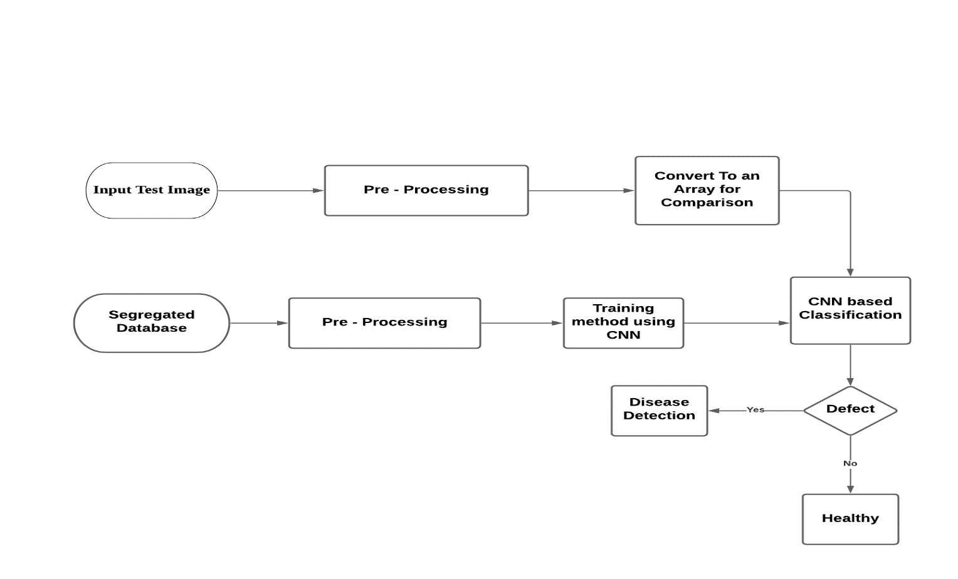

**Illustration2. SYSTEM PROCESS**

**RESULTS AND DISCUSSIONS**

**INFORMATION REGARDING THE DATASET**

**Kaggle** is an online community of data scientists and machine learning practitioners. Kaggle allows users to find and publish data sets, explore and build models in a web-based data-science environment, work with other data scientists and machine learning engineers, and enter competitions to solve data science challenges.

Kaggle got its start in 2010 by offering machine learning competitions and now also offers a public data platform, a cloud-based workbench for data science, and Artificial Intelligence education. This is where we extracted our dataset named **PLANT VILLAGE** and got started with our research on the leaf diseases of the Potato and Tomato. The author of the this dataset is Manikanta Munnangi, who is a research scholar from the Sri Ramaswamy Memorial Institute of Science and Technology, formerly **SRM** University.

We have primarily worked on two different crops **, POTATO** and **TOMATO.**

A brief introduction about the crops is given below:

**POTATO :** The potato plant has a branched stem and alternately arranged leaves consisting of leaflets which are both of unequal size and shape. The leaflets can be oval to oblong in shape and the leaves can reach 10–30 cm (4–12 in) in length and 5–15 cm (2–6 in) wide. The potato plant produces white or blue flowers and yellow-green berries. The potato tubers grow underground and generally located in the top 25 cm (10 in) of the soil. The tubers can range in colour from yellow to red or purple depending on the variety. Potato plants can reach in excess of 1 m (3.3 ft) in height and are grown as annual plants, surviving only one growing season.

**POTATO RELATED DISEASES:**

**Category : Fungal**

#### Potato Early Blight Alternaria solani

[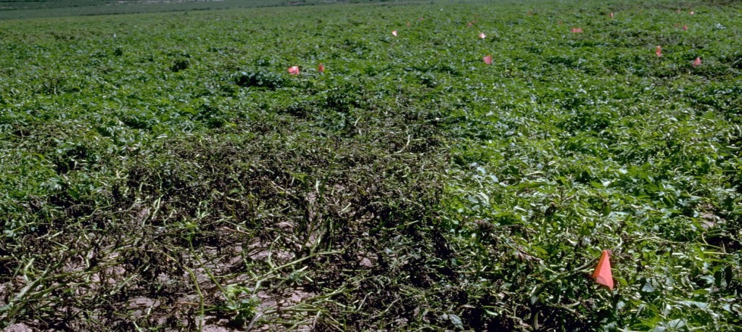](https://s3.amazonaws.com/plantvillage-production-new/images/pics/000/000/937/original/Early_blight_3.jpg?1374159600)

**Fig.1 Destruction of potato plants by early blight**

[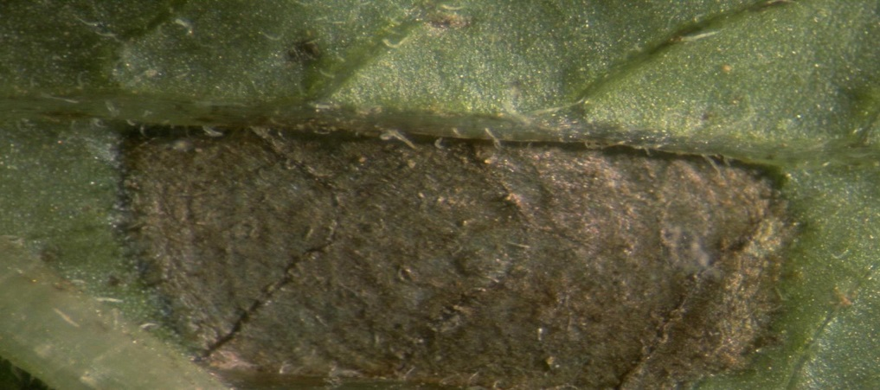](https://s3.amazonaws.com/plantvillage-production-new/images/pics/000/000/936/original/Early_blight_2.jpg?1374159448)

**Fig. 2 Close-up of leaf lesion caused by early blight**

[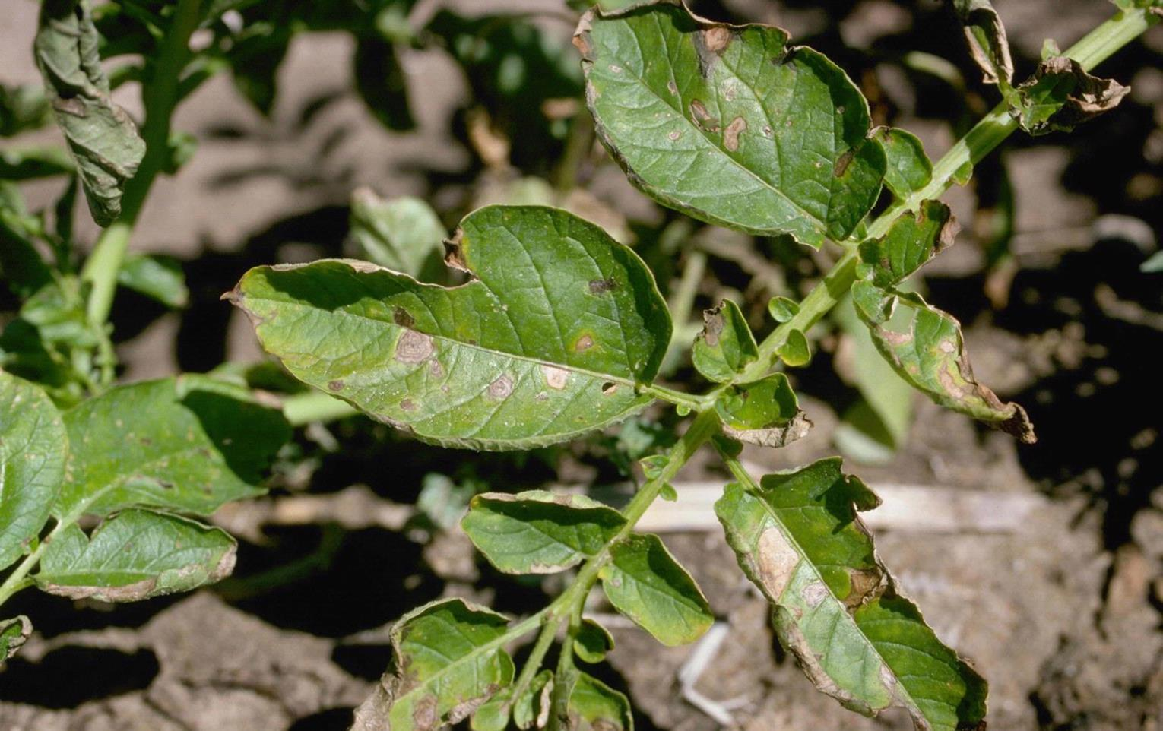](https://s3.amazonaws.com/plantvillage-production-new/images/pics/000/000/935/original/Early_blight_1.jpg?1374159307)

**Fig.3 Symptoms of early blight on potato foliage**

##### **Symptoms**

Dark lesions with yellow border which may form concentric rings of raised and sunken tissue on the leaves and stems; lesions initially circular but become angular; leaves become necrotic but remain attached to plant; dark, dry lesions on tubers with leathery or corky texture and watery yellow0green margins

##### **Cause**

Fungus

##### **Comments**

Disease emergence favours cycles of wet and dry conditions with periods of high humidity and leaf wetness

##### **Management**

Application of appropriate protective fungicide can reduce severity of foliar symptoms; reduce stress to plants by fertilizing and watering adequately; plant late varieties which are less susceptible to disease; store tubers in cool environment.

#### Category : Oomycete

#### Potato Late Blight Phytophthora infestan

#### 

**Fig.4 Potato plant destroyed by late blight**

[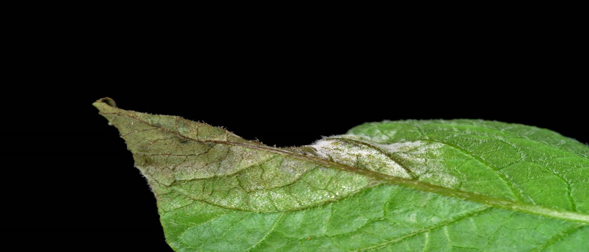](https://s3.amazonaws.com/plantvillage-production-new/images/pics/000/062/033/original/52837v_-_Copy.jpg?1449539382)

**Fig.5 Infected leaf showing the distinctive white sporulating area**

[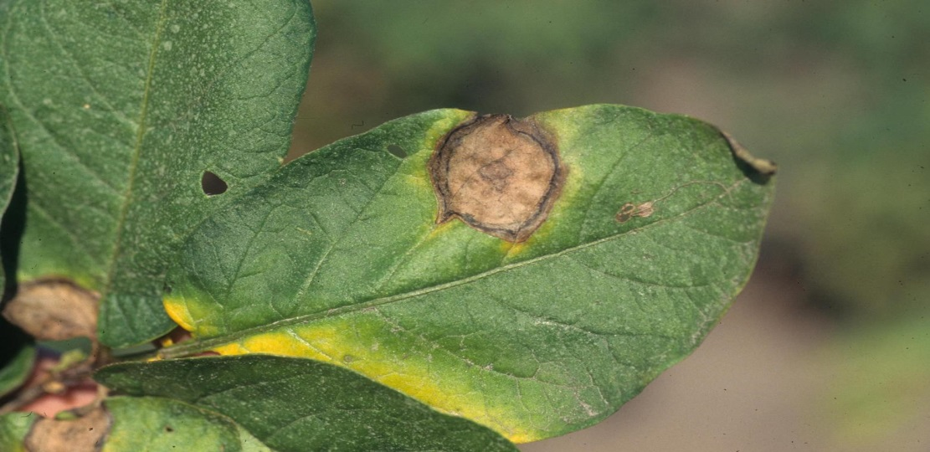](https://s3.amazonaws.com/plantvillage-production-new/images/pics/000/000/933/original/Late_blight_2.jpg?1374157575)

**Fig.6 Late blight lesions on leaf**

[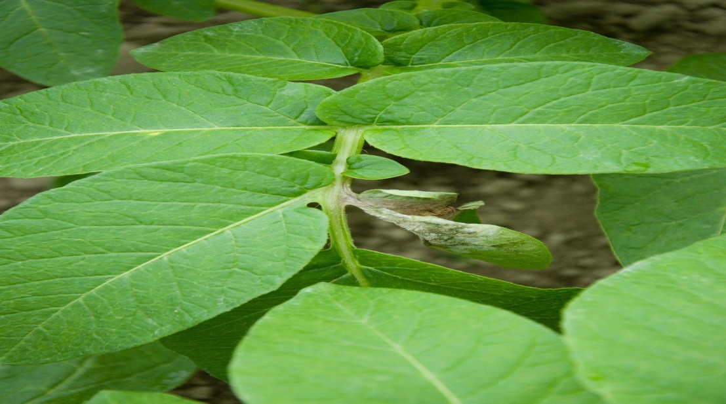](https://s3.amazonaws.com/plantvillage-production-new/images/pics/000/000/932/original/Late_blight_1.jpg?1374156421)

**Fig.7 Diseased leaf on potato plant**

##### **Symptoms**

Irregularly shaped spreading brown lesions on leaves with distinctive white fluffy sporulation at lesion margins on the underside of the leaf in wet conditions. In dry condition the lesions dry up and go dark brown with collapsed tissue; water-soaked dark green to brown lesions on stems also with characteristic white sporulation; later in infection leaves and petioles completely rotted; severely affected plants may have an slightly sweet distinctive odour; red-brown firm lesions on tubers extending several centimetres into tissue; lesions may be slightly sunken in appearance and often lead to secondary bacterial rots.

##### **Cause**

Oomycete

##### **Comments**

The pathogen can survive for several months to years in the soil; emergence of disease favoured by moist, cool conditions; major cause of disease spread is infected tubers

##### **Management**

Control depends on a multifaceted approach with importance of certain practices changing based on geographic location: destroy infected tubers; destroy any volunteer plants; application of appropriate fungicide to potato hills at emergence; time watering to reduce periods of leaf wetness e.g. water early to allow plant to dry off during the day; plant resistant varieties; apply appropriate protective fungicide if disease is forecast in area.

#### Category : Bacterial

#### Bacterial ring spot Clavibacter michiganensis

[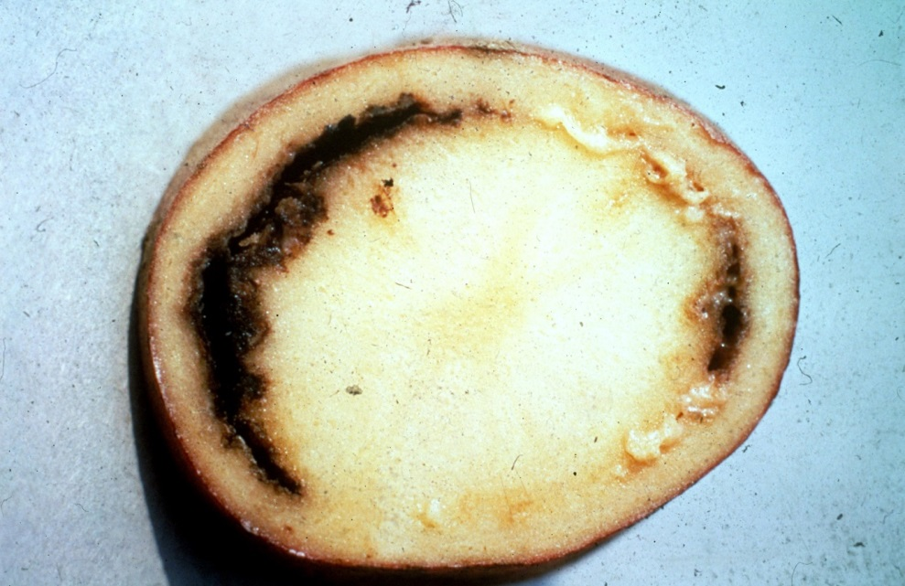](https://s3.amazonaws.com/plantvillage-production-new/images/pics/000/000/930/original/Ring_rot_2.jpg?1374090647)

**Fig.8 Cross-section of infected potato tuber showing ring of discoloured vascular tissue**

[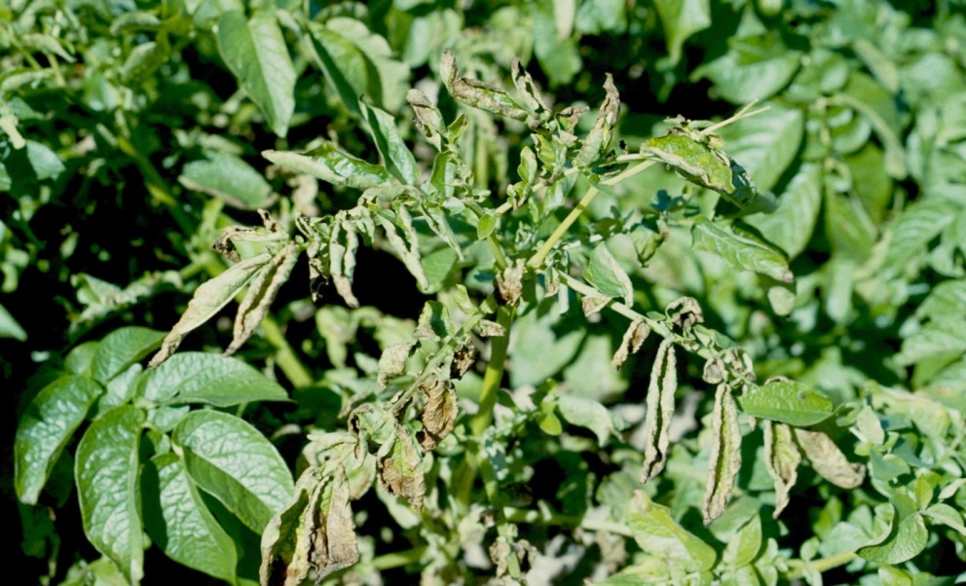](https://s3.amazonaws.com/plantvillage-production-new/images/pics/000/000/929/original/Ring_rot_1.jpg?1374090371)

**Fig.9 Potato plant showing ring rot symptoms**

##### **Symptoms**

Wilting stems and leaves; dying leaves; lower leaves wilting first; ring of creamy yellow to brown rot visible when tuber is cut crossways

##### **Cause**

Bacterium

##### **Comments**

Bacterium is tuber-borne; bacteria can enter tuber through cutting wounds; disease favoured by wet, warm soils; bacteria overwinter in potato debris

##### **Management**

Plant only certified seed potatoes - certified seed potatoes are grown in seed beds with zero tolerance of ring rot; remove all crop debris from soil after harvest; sanitize tools and equipment regularly.

**TOMATO :** Tomato is an herbaceous annual in the family Solanaceae grown for its edible fruit. The plant can be erect with short stems or vine-like with long, spreading stems. The stems are covered in coarse hairs and the leaves are arranged spirally. The tomato plant produces yellow flowers, which can develop into a cyme of 3–12, and usually a round fruit (berry) which is fleshy, smoothed skinned and can be red, pink, purple, brown, orange or yellow in colour. The tomato plant can grow 0.7–2 m (2.3–6.6 ft) in height and as an annual, is harvested after only one growing season.

**TOMATO RELATED DISEASES :**

#### Category : Fungal

#### Early blight

#### Alternaria solani

[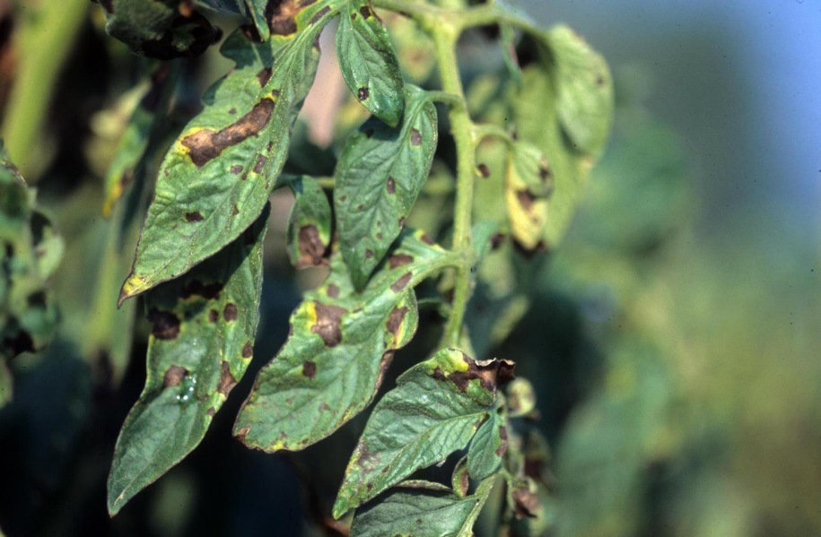](https://s3.amazonaws.com/plantvillage-production-new/images/pics/000/001/172/original/Early_blight_1.jpg?1376579808)

**Fig. 10 Early blight symptoms on tomato foliage**

[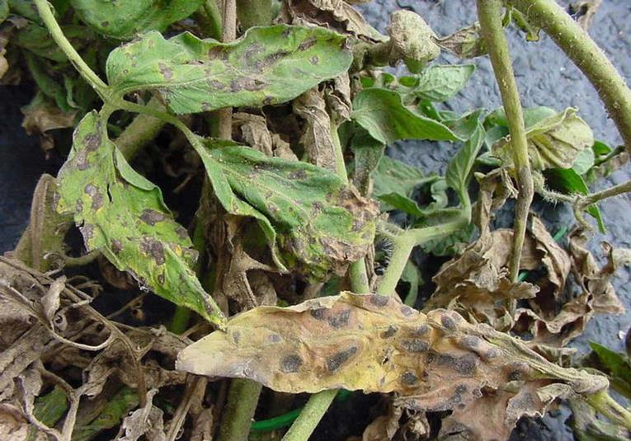](https://s3.amazonaws.com/plantvillage-production-new/images/pics/000/000/624/original/Early_blight_1.jpg?1369844143)

**Fig.11 Early blight symptoms on tomato foliage**

[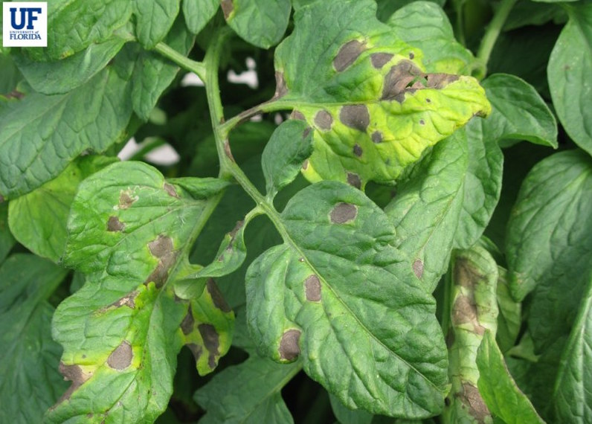](https://s3.amazonaws.com/plantvillage-production-new/images/pics/000/004/132/original/image_2.jpg?1421254709)

**Fig.12 Concentric leaf lesions can be seen on infected leaves**

[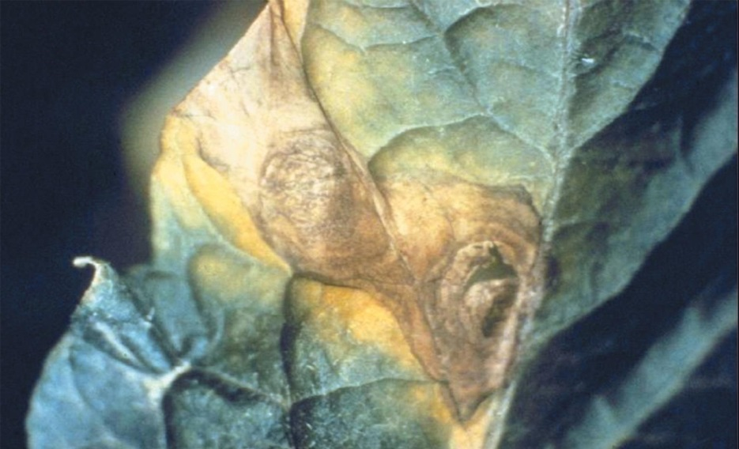](https://s3.amazonaws.com/plantvillage-production-new/images/pics/000/001/175/original/Early_blight_4.jpg?1376580263)

**Fig.13 Close up of early blight leaf lesion**

[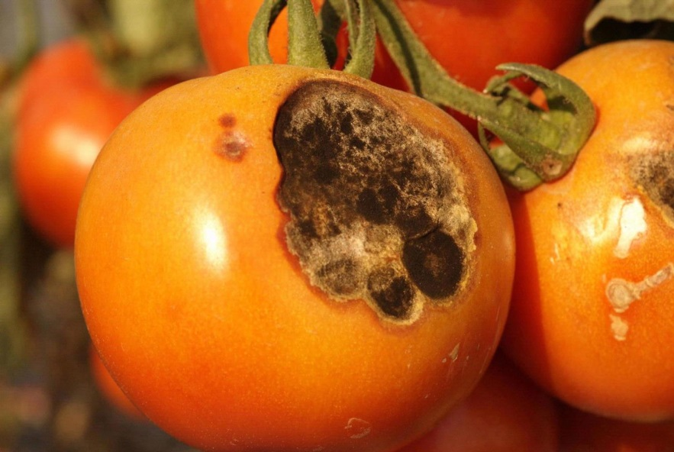](https://s3.amazonaws.com/plantvillage-production-new/images/pics/000/000/626/original/Early_blight_3.jpg?1369844363)

**Fig.14 Early blight symptoms on tomato fruit**

[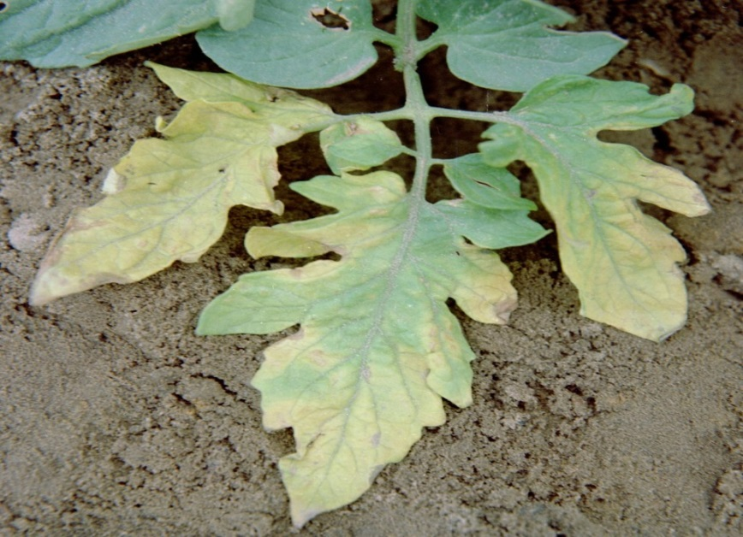](https://s3.amazonaws.com/plantvillage-production-new/images/pics/000/001/174/original/Early_blight_3.jpg?1376580079)

**Fig. 15 Early blight symptoms on tomato foliage**

[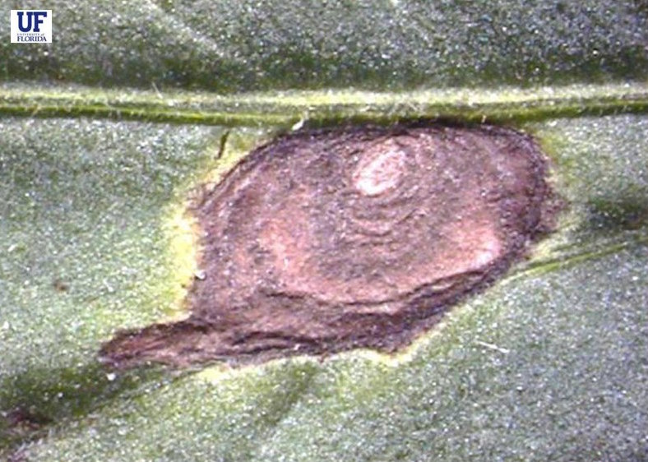](https://s3.amazonaws.com/plantvillage-production-new/images/pics/000/004/133/original/image_3.jpg?1421254783)

**Fig.16 The leaves completely collapse in severe infection.**

[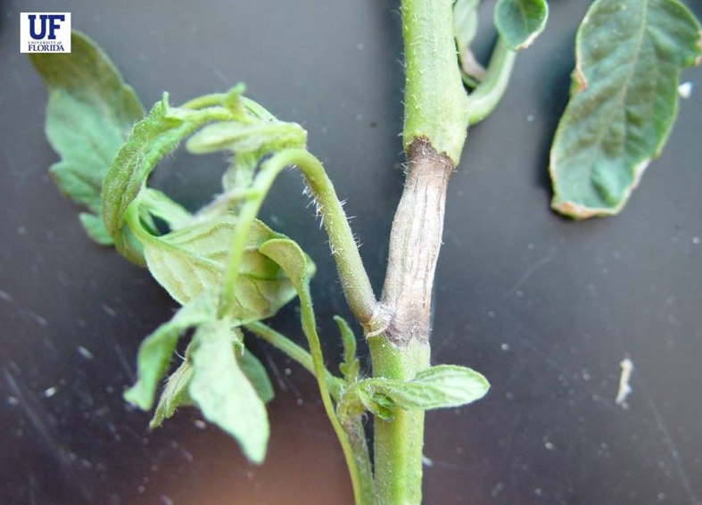](https://s3.amazonaws.com/plantvillage-production-new/images/pics/000/004/136/original/image_6.jpg?1421254951)

**Fig.16 The canker may enlarge to girdle the whole stem**

[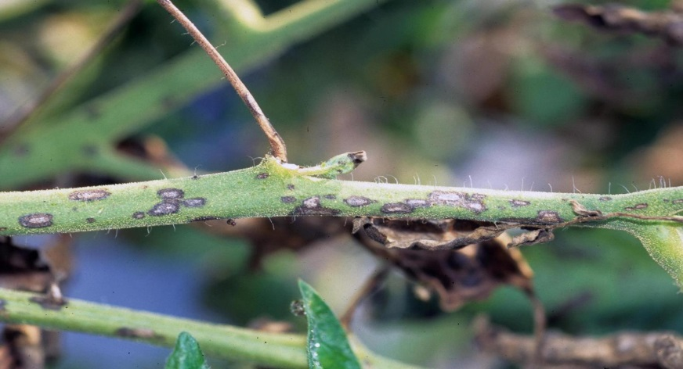](https://s3.amazonaws.com/plantvillage-production-new/images/pics/000/000/625/original/Early_blight_2.jpg?1369844262)

**Fig. 16 Early blight symptoms on tomato stem**

[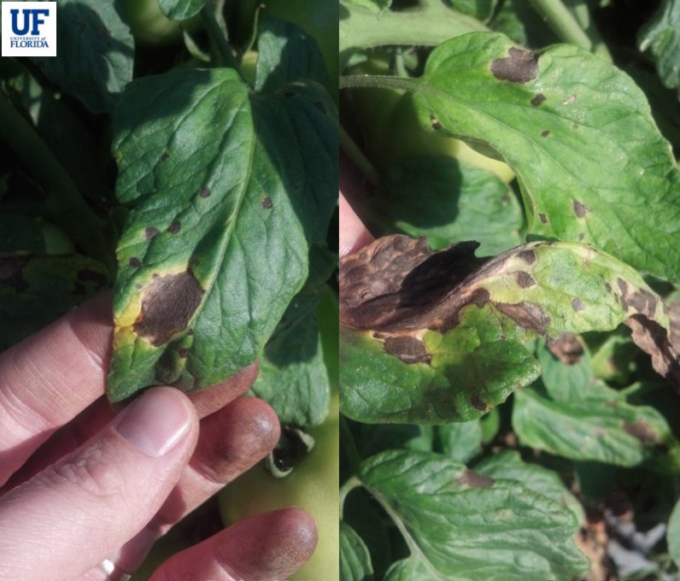](https://s3.amazonaws.com/plantvillage-production-new/images/pics/000/004/131/original/image_1.jpg?1421254644)

**Fig. 17 Oval shaped lesions with a yellow chlorotic region**

##### **Symptoms**

Early blight symptoms start as oval shaped lesions with a yellow chlorotic region across the lesion; concentric leaf lesions may be seen on infected leaves; leaf tissue between veins is destroyed; severe infections can cause leaves to completely collapse; as the disease progresses leaves become severely blighted leading to reduced yield; tomato stems may become infected with the fungus leading to Alternaria stem canker; initial symptoms of stem canker are the development of dark brown regions on the stem; stem cankers may enlarge to girdle the whole stem resulting in the death of the whole plant; brown streaks can be found in the vascular tissue above and below the canker region; fruit symptoms include small black V-shaped lesions at the shoulders of the fruit (the disease is also known black shoulder); lesions may also appear on the fruit as dark flecks with concentric ring pattern; fruit lesions can seen in the field or may develop during fruit transit to the market; the lesions may have a velvety appearance caused by sporulation of the fungus

##### **Cause**

Fungus

##### **Comments**

Disease can spread rapidly after plants have set fruit; movement of air-borne spores and contact with infested soil are causes for the spread of the disease

##### **Management**

Apply appropriate fungicide at first sign of disease; destroy any volunteer solanaceous plants (tomato, potato, nightshade etc); practice crop rotation

#### Category : Fungal

#### Leaf Mold Passalora fulva

[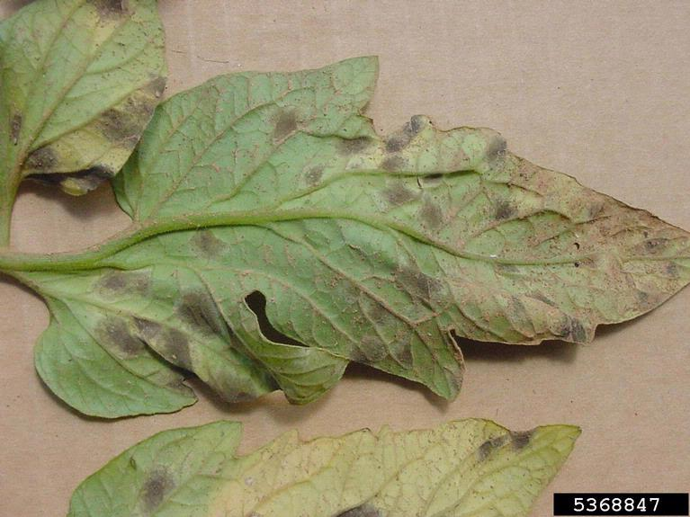](https://s3.amazonaws.com/plantvillage-production-new/images/pics/000/063/617/original/5368847-PPT.jpg?1473788745)

**Fig.18 Spots look diffuse with fuzzy growth on lower leaf surface.**

[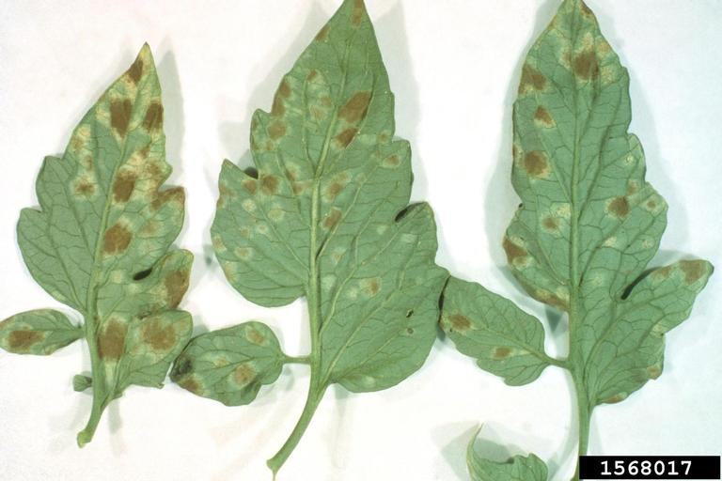](https://s3.amazonaws.com/plantvillage-production-new/images/pics/000/063/605/original/1568017-PPT.jpg?1473786394)

**Fig.19 Leaf mold symptoms on lower leaf surface**

[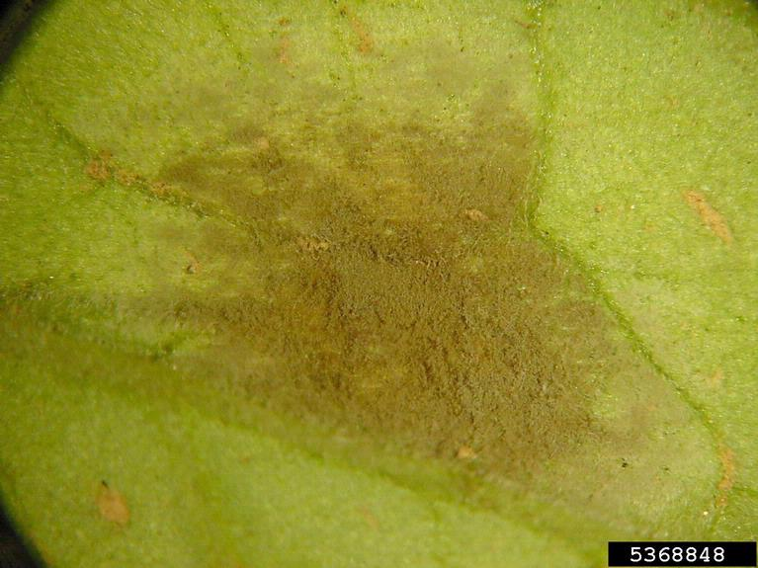](https://s3.amazonaws.com/plantvillage-production-new/images/pics/000/063/613/original/5368848-PPT.jpg?1473787990)

**Fig.20 Close-up of moldy growth on underside of leaf spot.**

[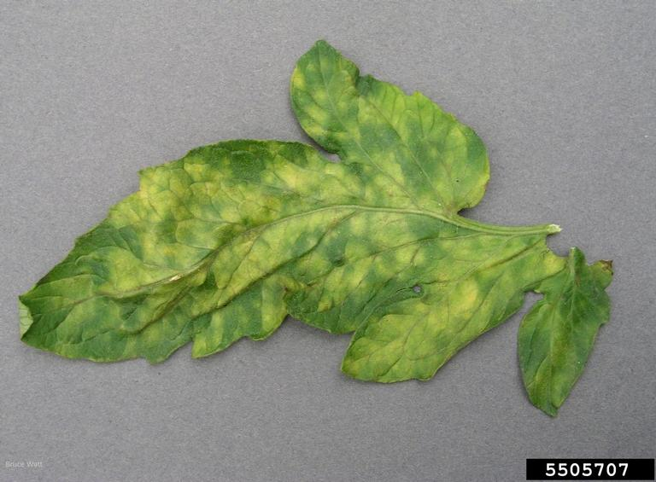](https://s3.amazonaws.com/plantvillage-production-new/images/pics/000/063/616/original/5505707-PPT.jpg?1473788620)

**Fig.21 Infected leaf, upper side**

[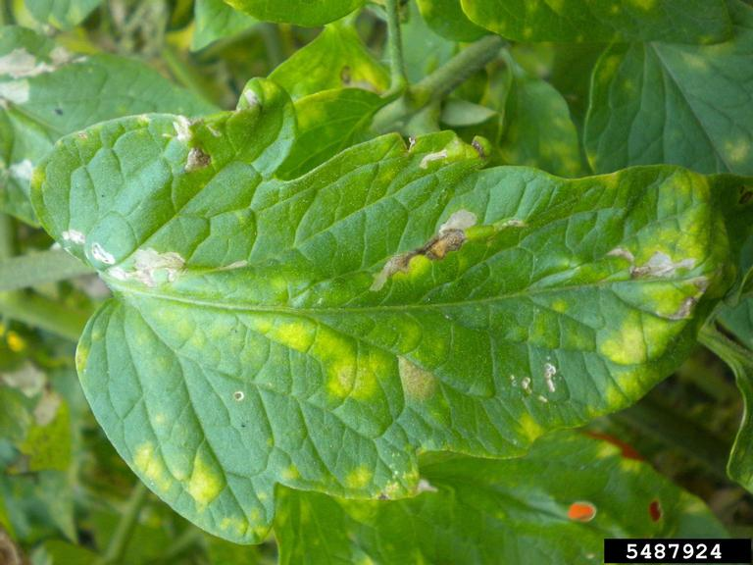](https://s3.amazonaws.com/plantvillage-production-new/images/pics/000/063/620/original/5487924-PPT.jpg?1473789170)

**Fig.22 Yellow spots**

[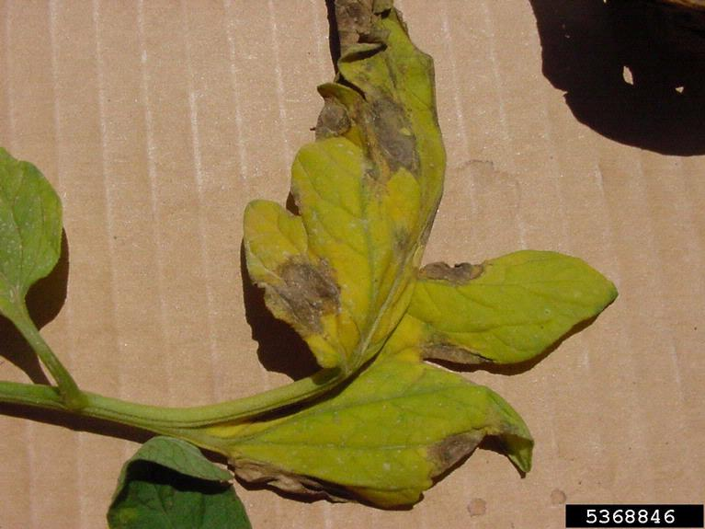](https://s3.amazonaws.com/plantvillage-production-new/images/pics/000/063/608/original/5368846-PPT.jpg?1473786833)

**Fig.23 Brown leaf spots on upper leaf surface**

[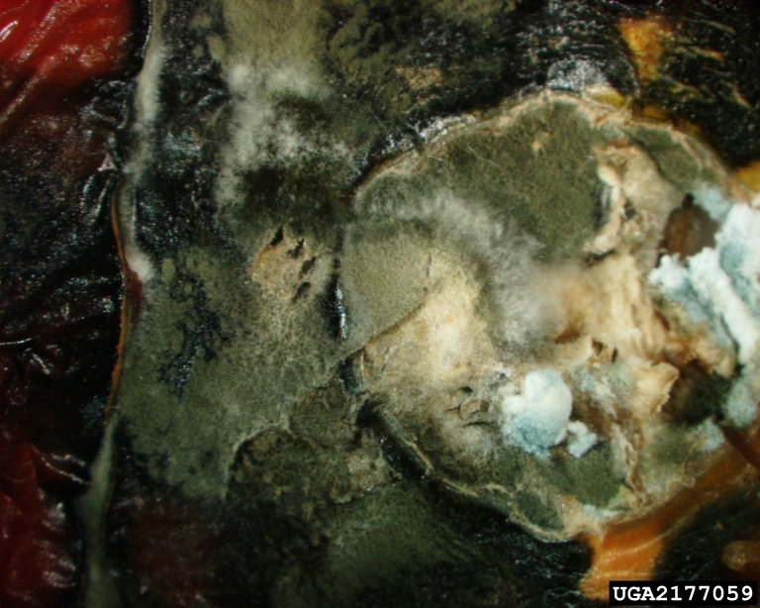](https://s3.amazonaws.com/plantvillage-production-new/images/pics/000/063/607/original/2177059-PPT.jpg?1473786635)

**Fig.24 Symptoms on leaf mold infected fruits**

[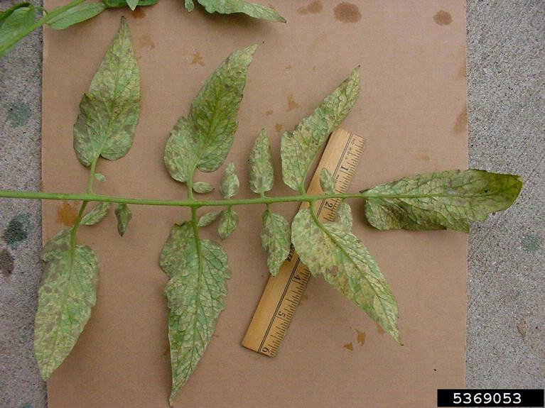](https://s3.amazonaws.com/plantvillage-production-new/images/pics/000/063/614/original/5369053-PPT.jpg?1473788335)

**Fig.25 Spots look diffuse on lower leaf surface.**

[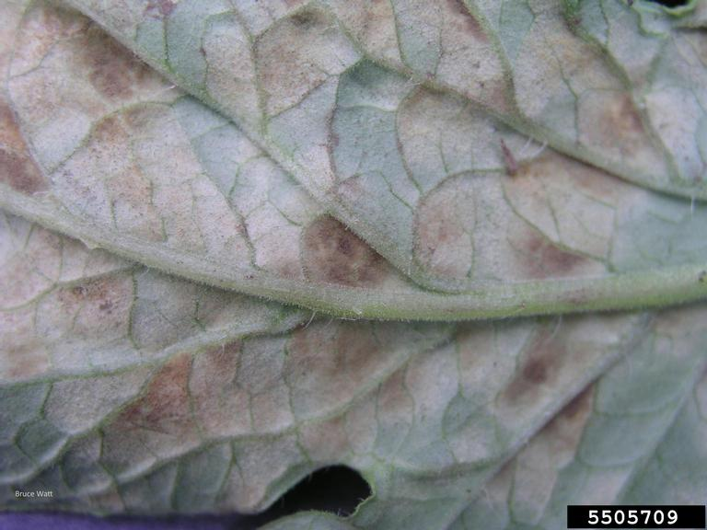](https://s3.amazonaws.com/plantvillage-production-new/images/pics/000/063/621/original/5505709-PPT.jpg?1473789391)

**Fig.26 Brown, felt-like patches of conidia on lower leaf surface**

[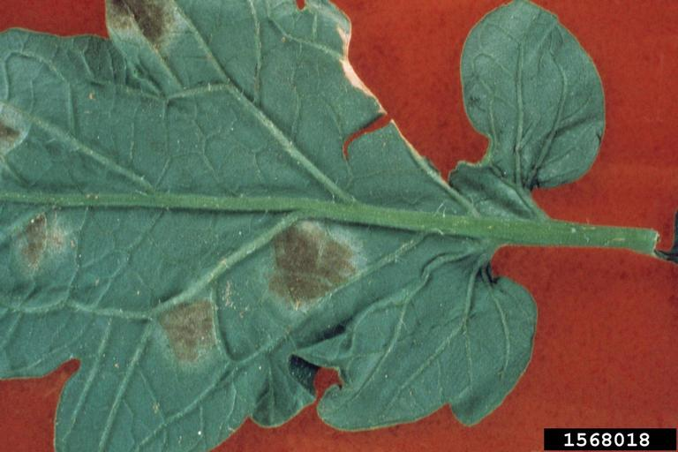](https://s3.amazonaws.com/plantvillage-production-new/images/pics/000/063/606/original/1568018-PPT.jpg?1473786395)

**Fig.27 Symptoms on lower surface**

[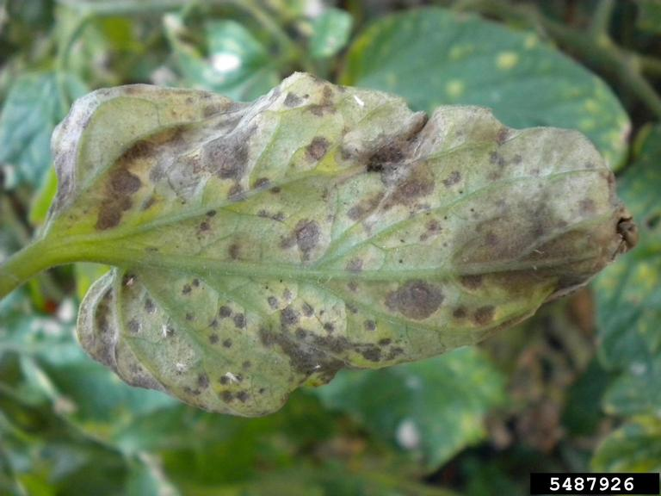](https://s3.amazonaws.com/plantvillage-production-new/images/pics/000/063/611/original/5487926-PPT.jpg?1473786977)

**Fig.28 Leaf spots and sporulation on underside of leaf**

[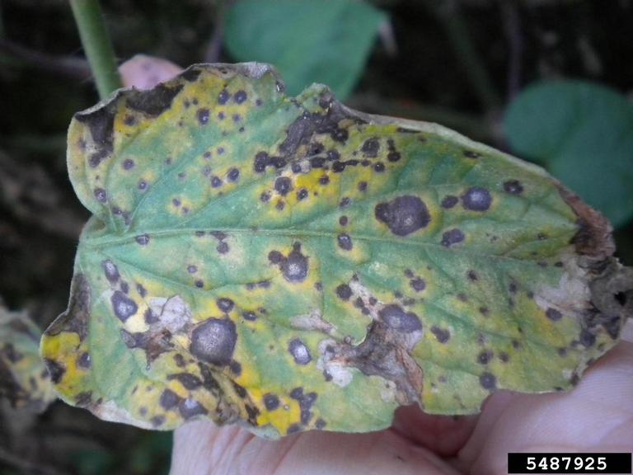](https://s3.amazonaws.com/plantvillage-production-new/images/pics/000/063/615/original/5487925-PPT.jpg?1473788491)

**Fig. 29 Spots on upper leaf surface due to leaf mold fungus**

[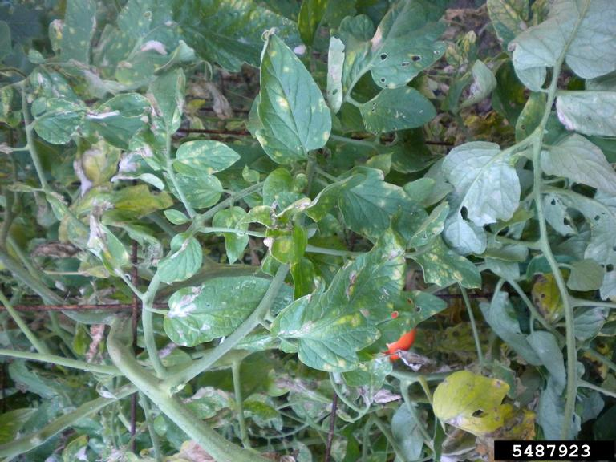](https://s3.amazonaws.com/plantvillage-production-new/images/pics/000/063/619/original/5487923-PPT.jpg?1473789033)

**Fig.30 Yellow spots due leaf mold**

[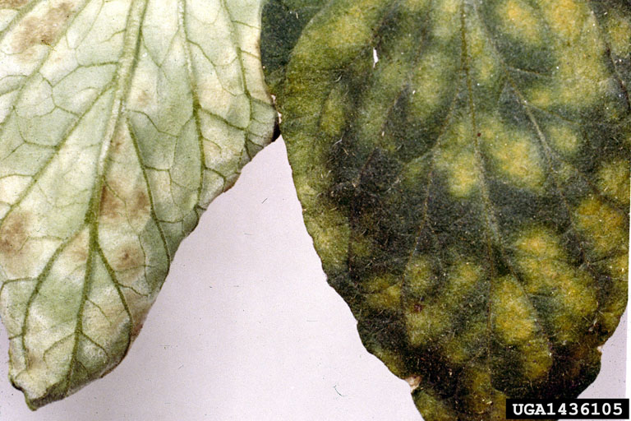](https://s3.amazonaws.com/plantvillage-production-new/images/pics/000/063/622/original/1436105-PPT.jpg?1473789585)

**Fig.31 Leaf mold symptoms**

##### **Symptoms**

The older leaves exhibit pale greenish to yellow spots (without distinguishable margins) on upper surface. Whereas the lower portion of this spots exhibit green to brown velvety fungal growth. As the disease progress the spots may coalesce and appear brown. The infected leaves become wither and die but stay attached to the plant. The fungus also infects flowers and fruits. The affected flowers become black and drop off. The affected fruit intially shows smooth black irregular area on the stem end but later it becomes sunken, leathery and dry.

##### **Cause**

Fungus

##### **Comments**

The disease is favored by high relative humidity. Also a common disease in green house tomato crop.

##### **Management**

Grow available resistant varieties. Avoid leaf wetting and overhead application of water. Follow proper spacing to provide good air circulation around the plants. Remove the infected plant debris and burn them. If the disease is severe scary suitable fungicide

#### Category : Fungal

#### Septoria leaf spot Septoria lycopersici

[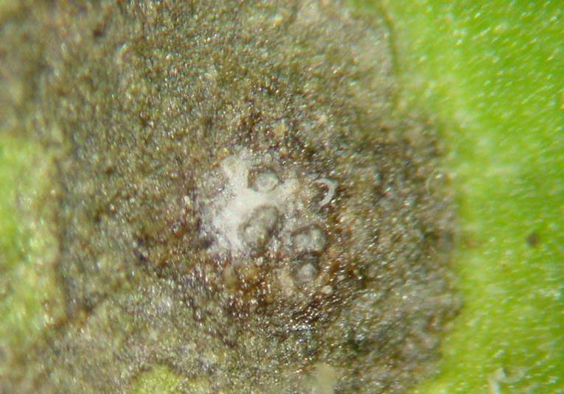](https://s3.amazonaws.com/plantvillage-production-new/images/pics/000/001/191/original/5369150-PPT.jpg?1376589865)

**Fig.32 Close-up of leaf lesion showing gray-white center with fungal fruiting bodies**

[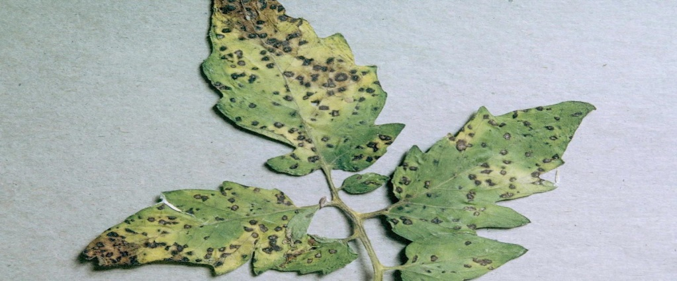](https://s3.amazonaws.com/plantvillage-production-new/images/pics/000/000/632/original/Septoria_leaf_spot_2.jpg?1369845222)

**Fig.33 Septoria leaf spot symptoms on tomato leaf**

[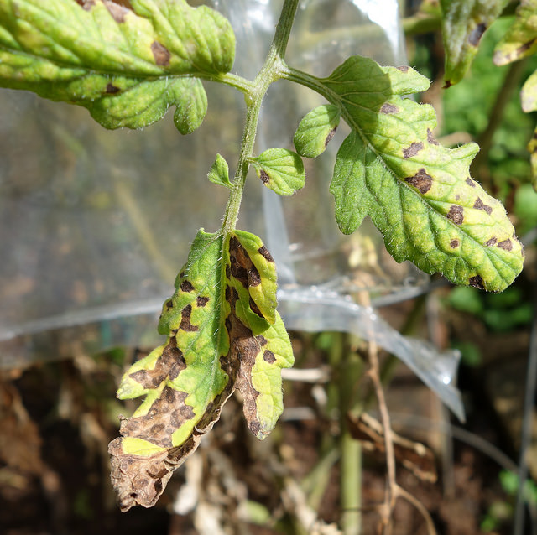](https://s3.amazonaws.com/plantvillage-production-new/images/pics/000/003/653/original/14460168739_da1a134d90_z.jpg?1415028260)

**Fig.34 Septori leaf spot symptoms on tomato foliage**

[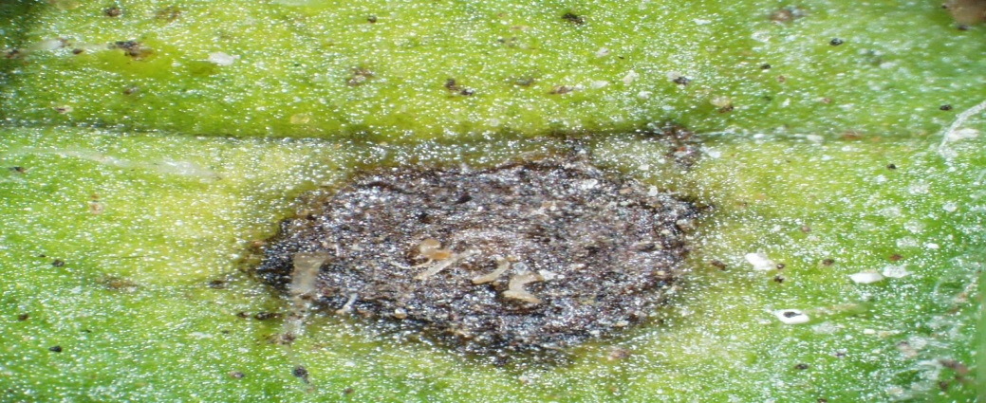](https://s3.amazonaws.com/plantvillage-production-new/images/pics/000/001/189/original/5411325-SMPT.jpg?1376589518)

**Fig.35 Close-up of a Septoria lesion on tomato**

[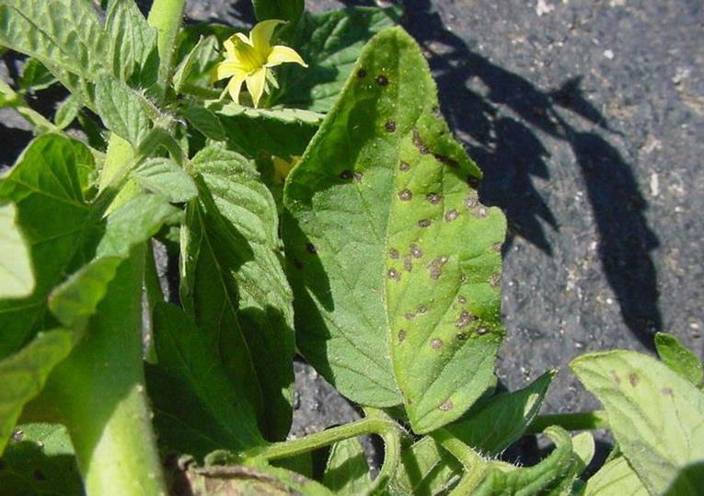](https://s3.amazonaws.com/plantvillage-production-new/images/pics/000/001/190/original/5369149-PPT.jpg?1376589694)

**Fig.36 Symptoms of Septoria leaf spot on tomato foliage**

[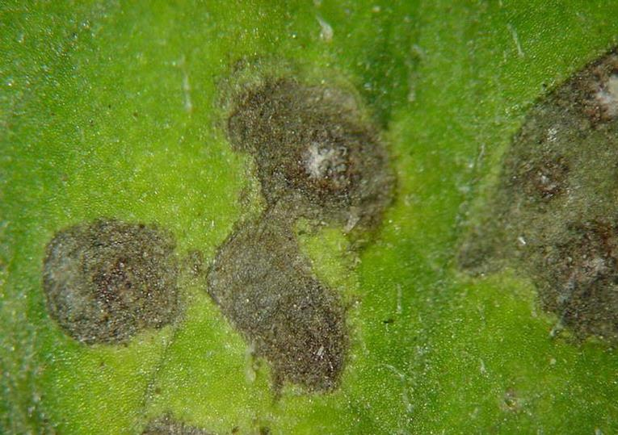](https://s3.amazonaws.com/plantvillage-production-new/images/pics/000/000/631/original/Septoria_leaf_spot_1.jpg?1369845122)

**Fig.37 Septoria leaf spot lesion on tomato leaf**

[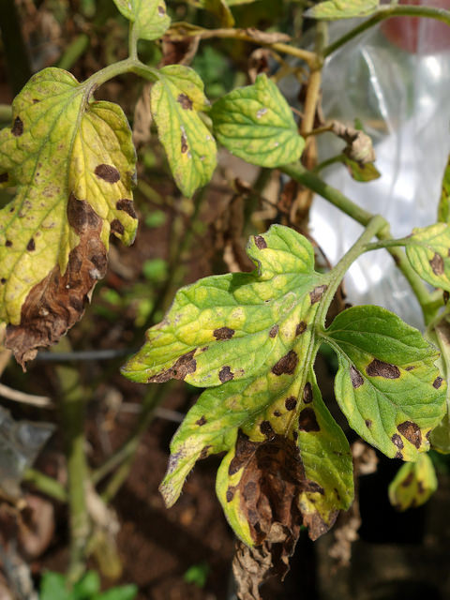](https://s3.amazonaws.com/plantvillage-production-new/images/pics/000/003/652/original/14666697003_2d0c8fb5d8_z.jpg?1415028206)

**Fig.38 Septoria leaf spot symptoms on tomato foliage**

##### **Symptoms**

Symptoms may occur at any stage of tomato development and begin as small, water-soaked spots or circular grayish-white spots on the underside of older leaves; spots have a grayish center and a dark margin and they may colasece; fungal fruiting bodies are visible as tiny black specks in the center of spot; spots may also appear on stems, fruit calyxes, and flowers.

##### **Cause**

Fungus

##### **Comments**

Spread by water splash; fungus overwinters in plant debris.

##### **Management**

Ensure all tomato crop debris is removed and destroyed in Fall or plowed deep into soil; plant only disease-free material; avoid overhead irrigation; stake plants to increase air circulation through the foliage; apply appropriate fungicide if necessary.

#### Category : Fungal

#### Target Spot Corynespora cassiicola

[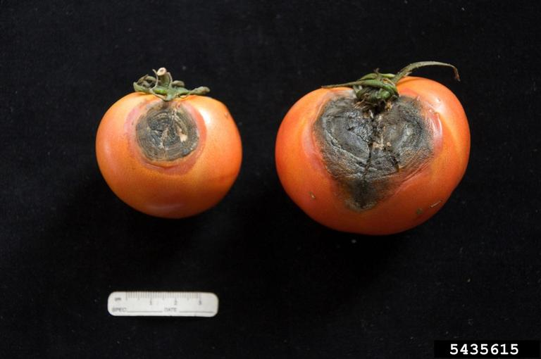](https://s3.amazonaws.com/plantvillage-production-new/images/pics/000/063/624/original/5435615-PPT.jpg?1473797983)

**Fig.39 Black lesions with conidia**

**Symptoms**

The fungus infects all parts of plant. Infected leaves shows small, pinpoint, water soaked spots initially. As the disease progress the spots enlarge to become necrotic lesions with conspicuous concentric circles, dark margins and light brown centers. Whereas the fruits exhibit brown, slightly sunken flecks in the beginning but later the lesions become large pitted appearance.

##### **Cause**

Fungus

##### **Comments**

The pathogen infects cucumber, pawpaw , ornamental plants, some weed species etc. The damaged fruits are susceptible for this disease.

##### **Management**

Remove the plant debris and burn them. Avoid over application of nitrogen fertilizer. If the disease is severe spray suitable fungicides.

#### Bacterial spot

[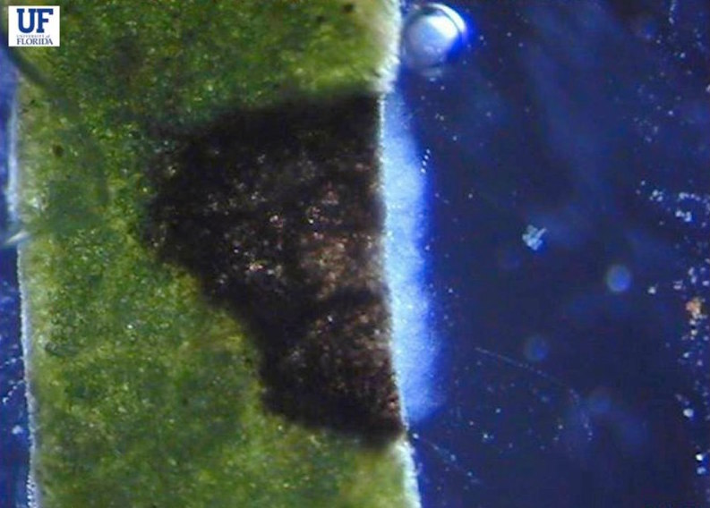](https://s3.amazonaws.com/plantvillage-production-new/images/pics/000/004/128/original/image_13.jpg?1421253865)

**Fig. 40 Leaves will ooze from the cut end only in case of bacterial spot**

[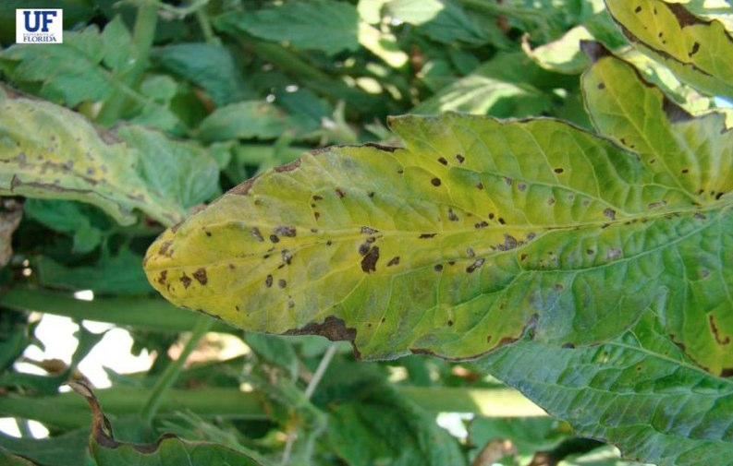](https://s3.amazonaws.com/plantvillage-production-new/images/pics/000/004/121/original/image_6.jpg?1421253330)

**Fig.41 Severe infections causes the leaves to look blighted**

[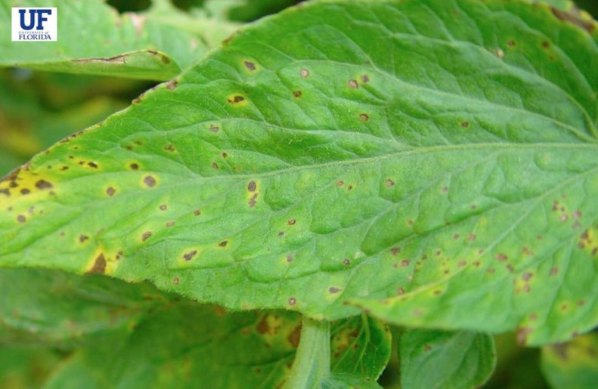](https://s3.amazonaws.com/plantvillage-production-new/images/pics/000/004/118/original/image_3.jpg?1421253041)

**Fig.42 Symptoms of bacterial spot on tomato foliage**

[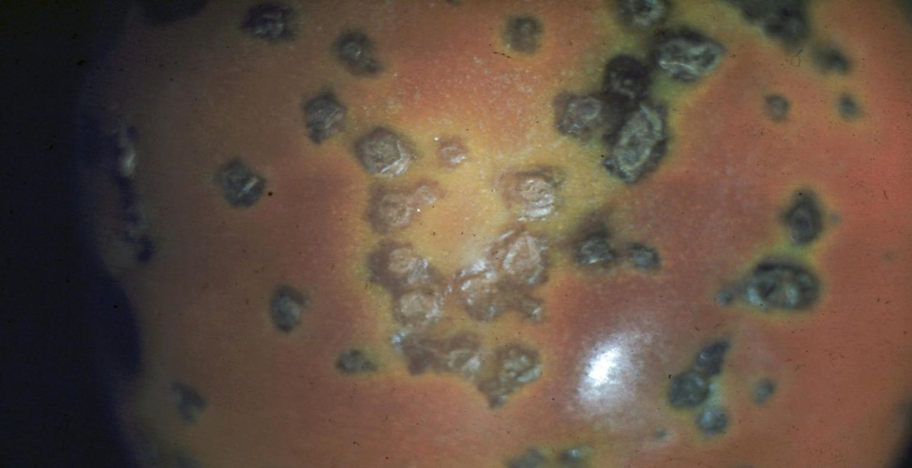](https://s3.amazonaws.com/plantvillage-production-new/images/pics/000/001/167/original/Bacterial_spot_4.jpg?1376578672)

**Fig.43 Symptoms of bacterial spot on tomato fruit**

[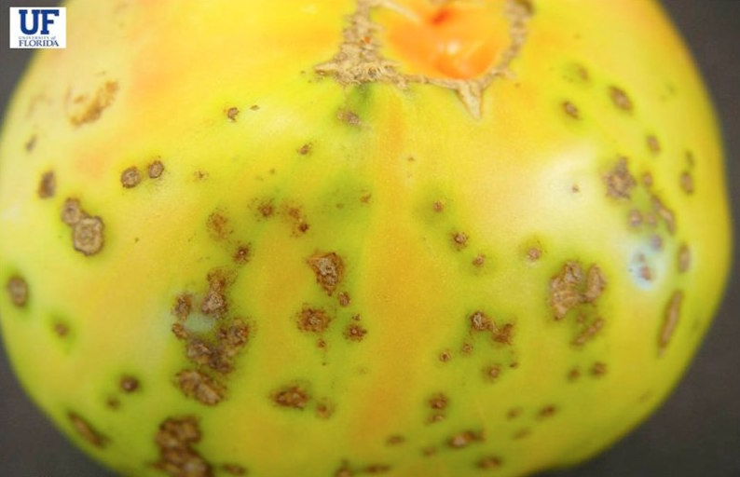](https://s3.amazonaws.com/plantvillage-production-new/images/pics/000/004/127/original/image_12.jpg?1421253818)

**Fig.44 Fruit spots can also be slightly raised and scabby looking**

[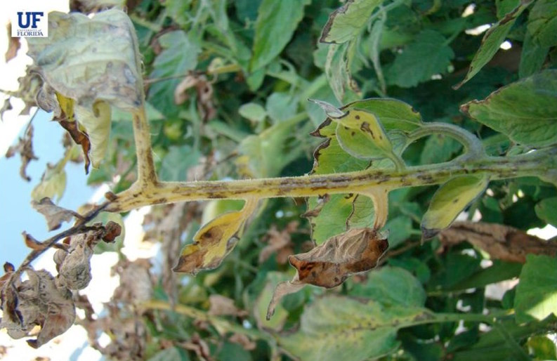](https://s3.amazonaws.com/plantvillage-production-new/images/pics/000/004/122/original/image_7.jpg?1421253407)

**Fig.45 Petioles with spot lesions are turning yellow followed by complete necrosis**

[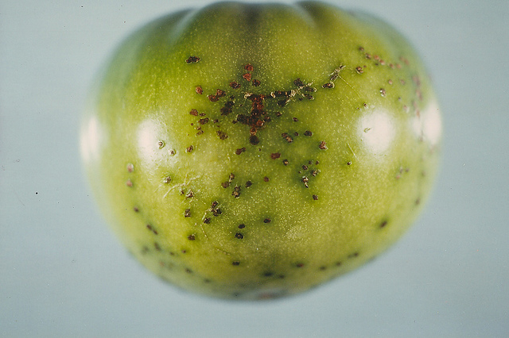](https://s3.amazonaws.com/plantvillage-production-new/images/pics/000/003/635/original/9101555371_59311c1186_z.jpg?1415026941)

**Fig.46 Symptoms of bacterial spot on tomato fruit**

[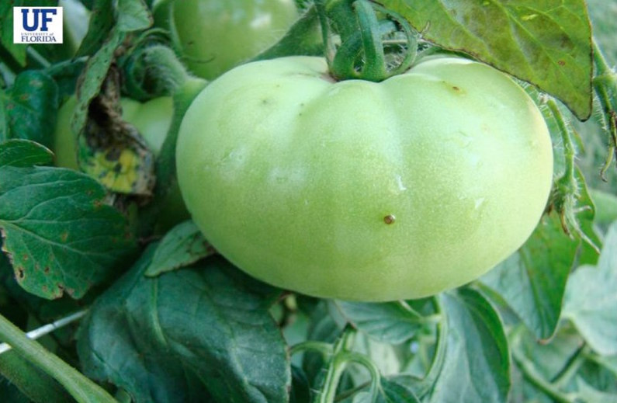](https://s3.amazonaws.com/plantvillage-production-new/images/pics/000/004/124/original/image_9.jpg?1421253663)

**Fig.47 Fruit infections start as a slightly raised blister**

[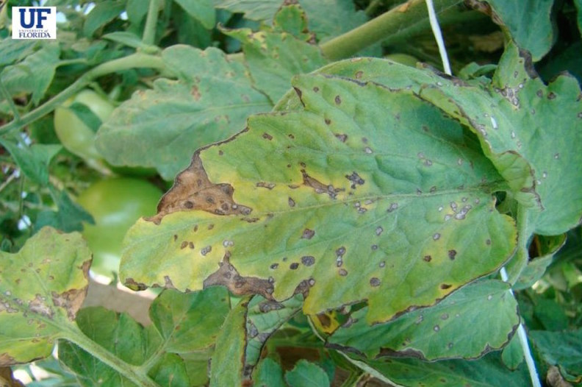](https://s3.amazonaws.com/plantvillage-production-new/images/pics/000/004/120/original/image_5.jpg?1421253262)

**Fig.48 Lesions may coalesce forming necrotic areas on the leaf giving it a blighted appearance**

[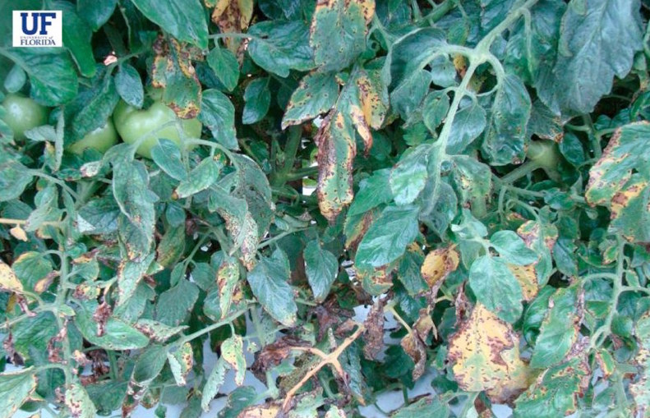](https://s3.amazonaws.com/plantvillage-production-new/images/pics/000/004/116/original/image_1.jpg?1421251026)

**Fig.49 Bacterial spot causes significant crop losses during rainy conditions**

[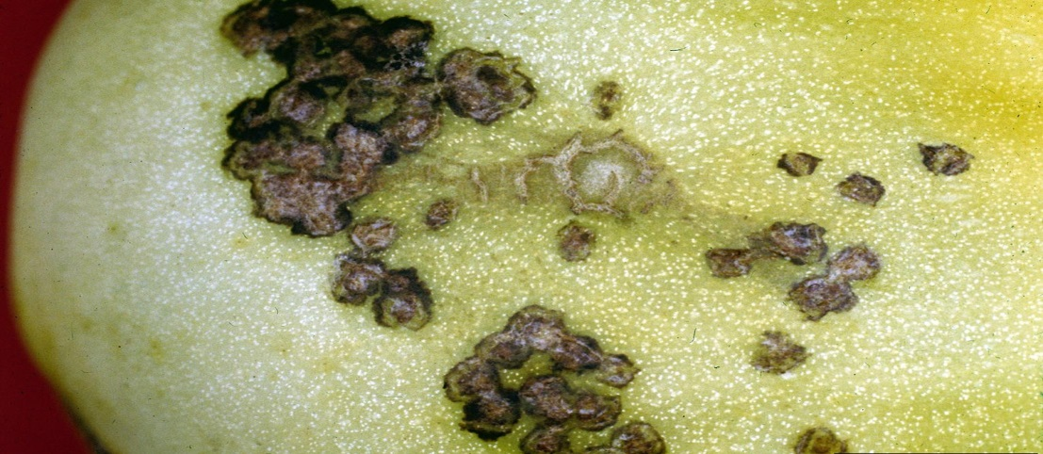](https://s3.amazonaws.com/plantvillage-production-new/images/pics/000/001/166/original/Bacterial_spot_3.jpg?1376578553)

**Fig.50 Symptoms of bacterial spot on tomato fruit**

[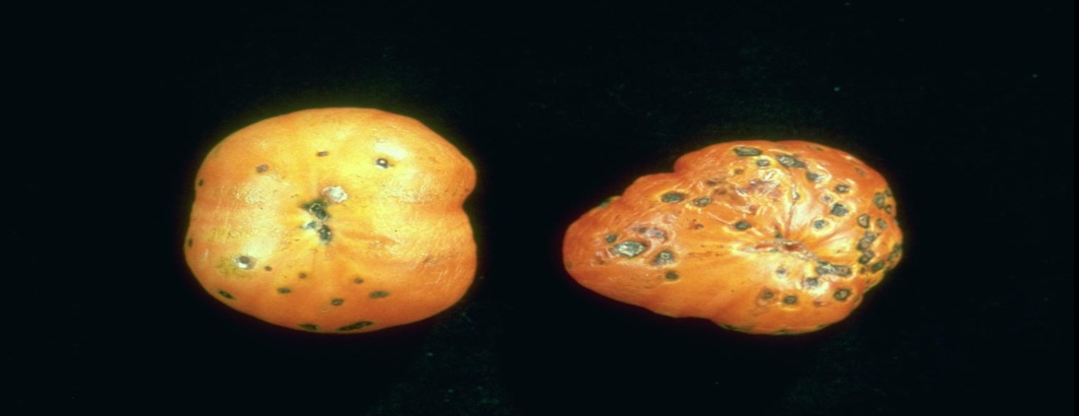](https://s3.amazonaws.com/plantvillage-production-new/images/pics/000/000/621/original/Bacterial_spot_2.jpg?1369843621)

**Fig.51 Bacterial spot symptoms on tomato fruit**

[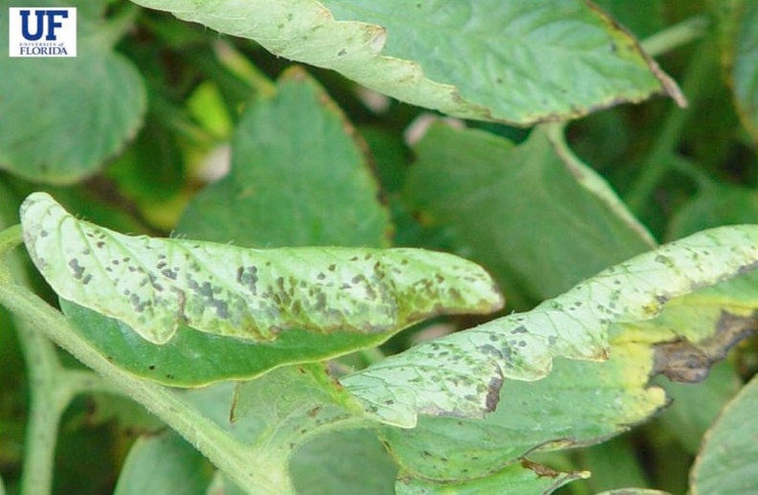](https://s3.amazonaws.com/plantvillage-production-new/images/pics/000/004/117/original/image_2.jpg?1421252556)

**Fig.52 Bacterial spot lesions starts out as small water-soaked spots.**

[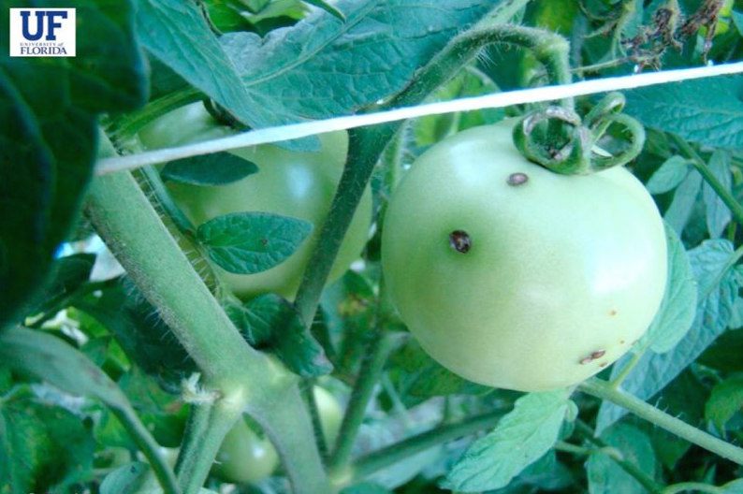](https://s3.amazonaws.com/plantvillage-production-new/images/pics/000/004/125/original/image_10.jpg?1421253717)

**Fig. 53 Lesions on the fruit can also be raised around the margins and sunken in the middle**

[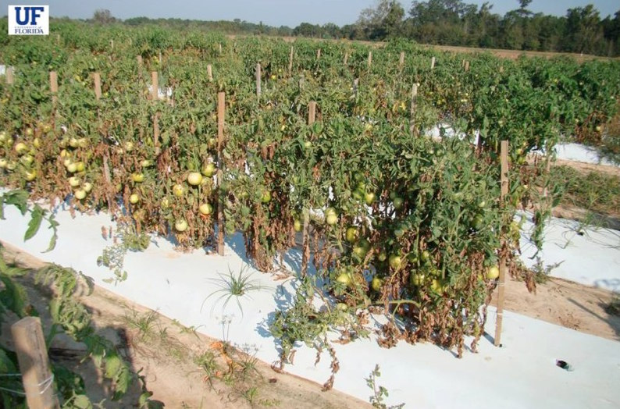](https://s3.amazonaws.com/plantvillage-production-new/images/pics/000/004/123/original/image_8.jpg?1421253599)

**Fig.54 Severe defoliation of infected plants can occur leading to a blighted look in large tomato fields**

[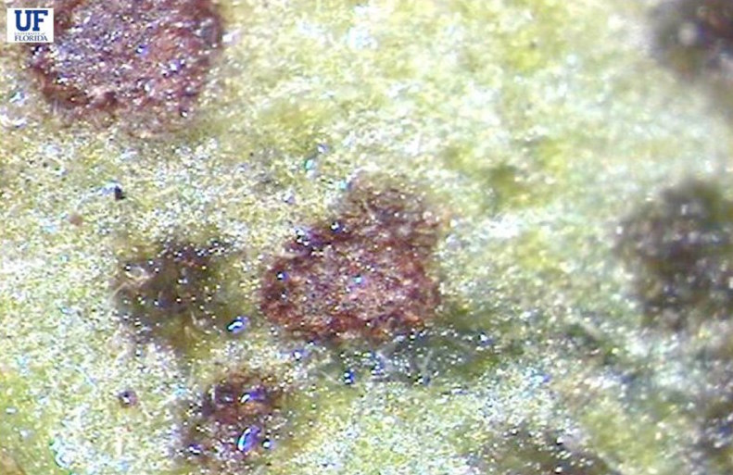](https://s3.amazonaws.com/plantvillage-production-new/images/pics/000/004/119/original/image_4.jpg?1421253120)

**Fig.55 Mature spots, with or without yellowing have a greasy appearance and can be transparent**

[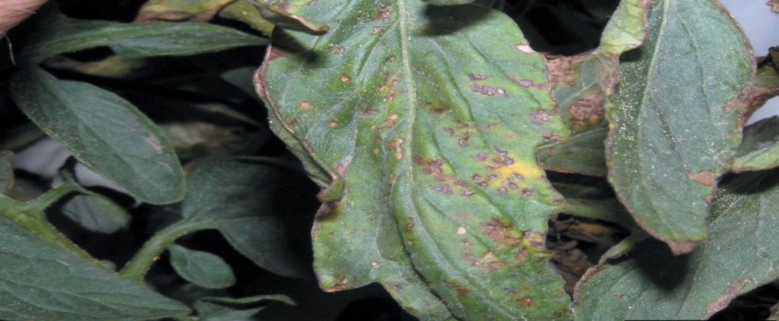](https://s3.amazonaws.com/plantvillage-production-new/images/pics/000/001/169/original/Bacterial_spot_6.jpg?1376579024)

**Fig.56 Symptoms of bacterial spot on tomato foliage**

[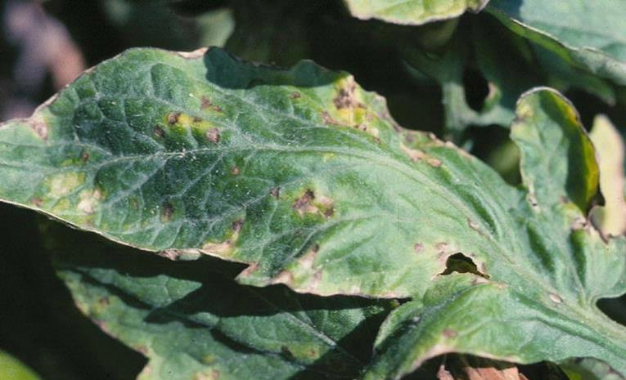](https://s3.amazonaws.com/plantvillage-production-new/images/pics/000/001/165/original/Bacterial_spot_2.jpg?1376578418)

**Fig.57 Symptoms of bacterial spot on tomato foliage**

[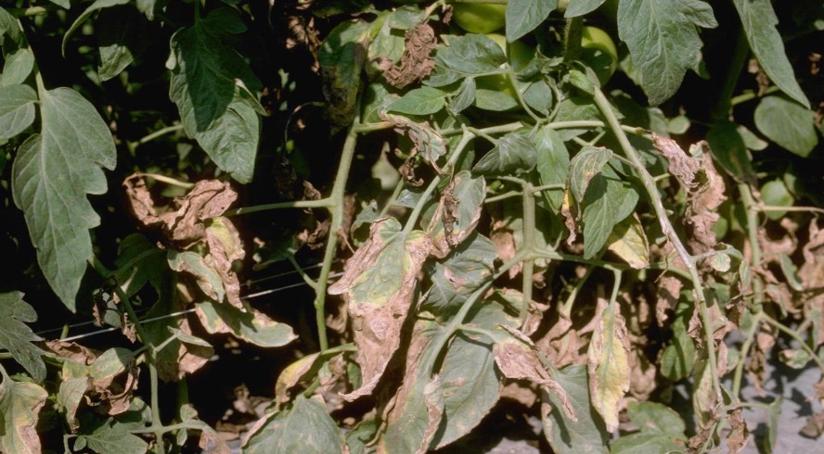](https://s3.amazonaws.com/plantvillage-production-new/images/pics/000/000/620/original/Bacterial_spot_1.jpg?1369843465)

**Fig.58 Bacterial spot symptoms on tomato foliage**

[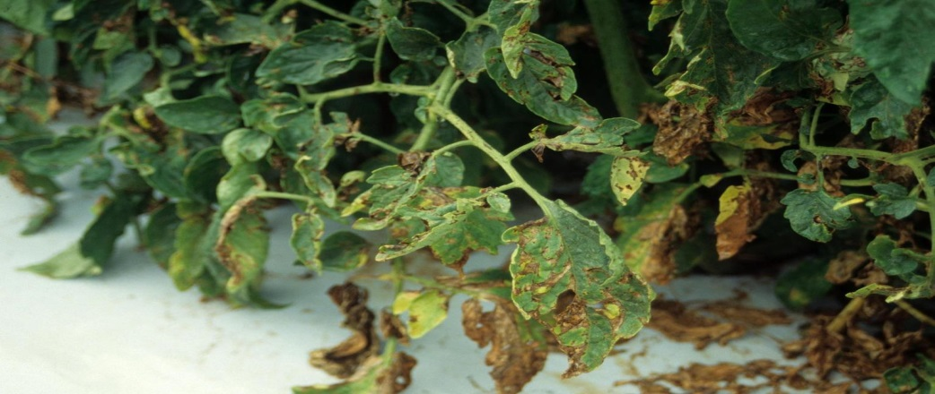](https://s3.amazonaws.com/plantvillage-production-new/images/pics/000/001/168/original/Bacterial_spot_5.jpg?1376578867)

**Fig.59 Symptoms of bacterial spot on tomato foliage**

[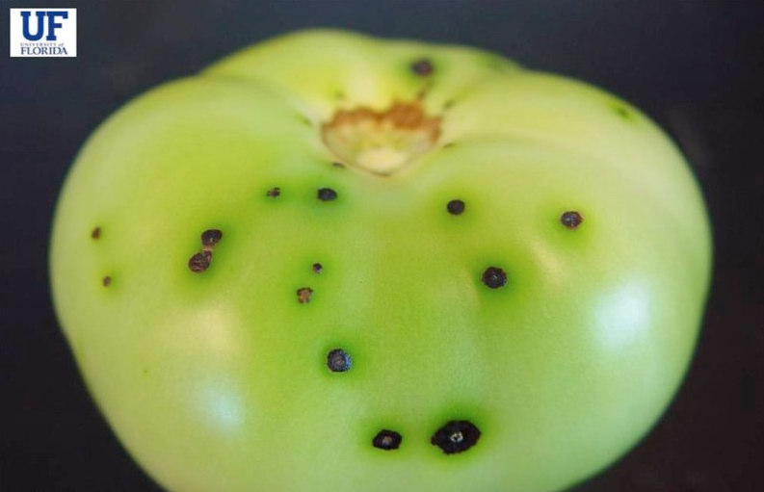](https://s3.amazonaws.com/plantvillage-production-new/images/pics/000/004/126/original/image_11.jpg?1421253772)

**Fig.60 Lesions on the fruit can also be raised around the margins and sunken in the middle**

##### **Symptoms**

Bacterial spot lesions starts out as small water-soaked spots; lesions become more numerous and coalesce to form necrotic areas on the leaves giving them a blighted appearance; of leaves drop from the plant severe defoliation can occur leaving the fruit susceptible to sunscald; mature spots have a greasy appearance and may appear transparent when held up to light; centers of lesions dry up and fall out of the leaf; blighted leaves often remain attached to the plant and give it a blighted appearance; fruit infections start as a slightly raised blister; lesions may have a faint halo which eventually disappears; lesions on fruit may have a raised margin and sunken center which gives the fruit a scabby appearance.

##### **Cause**

Bacterium

##### **Comments**

Bacteria survive on crop debris; disease emergence favored by warm temperatures and wet weather; symptoms are very similar to other tomato diseases but only bacterial spot will cause a cut leaf to ooze bacterial exudate; the disease is spread by infected seed, wind-driven rain, diseased transplants, or infested soil; bacteria enter the plant through any natural openings on the leaves or any openings caused by injury to the leaves.

##### **Management**

Use only certified seed and healthy transplants; remove all crop debris from planting area; do not use sprinkler irrigation, instead water from base of plant; rotate crops.

#### Category : Oomycete

#### Late blight Phytophthora infestans

[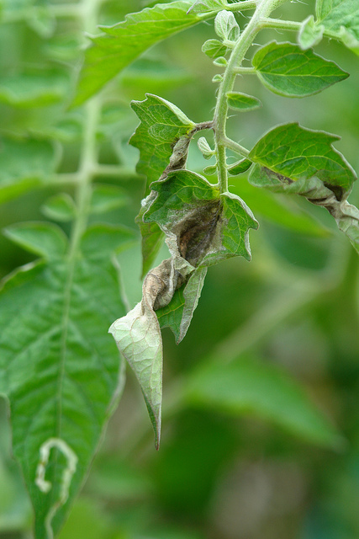](https://s3.amazonaws.com/plantvillage-production-new/images/pics/000/003/650/original/5816171413_57a9512966_z.jpg?1415028033)

**Fig.61 Late blight symptoms on tomato leaves**

[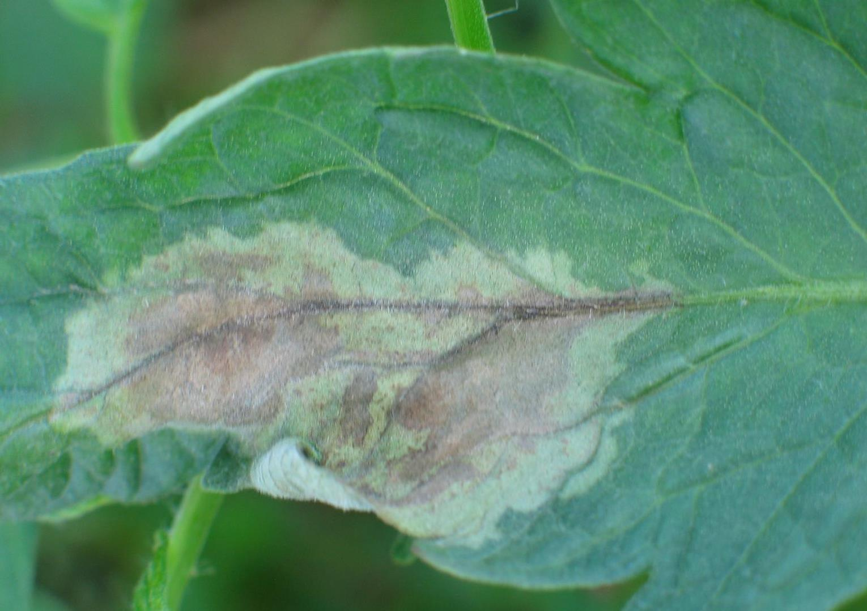](https://s3.amazonaws.com/plantvillage-production-new/images/pics/000/001/187/original/5470381-SMPT.jpg?1376589217)

**Fig.62 Late blight lesion on tomato leaf**

[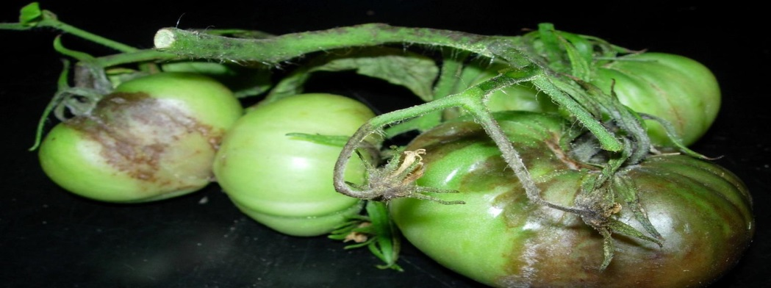](https://s3.amazonaws.com/plantvillage-production-new/images/pics/000/001/184/original/Picture27.jpg?1376588920)

**Fig.63 Late blight symptoms on tomato fruit**

[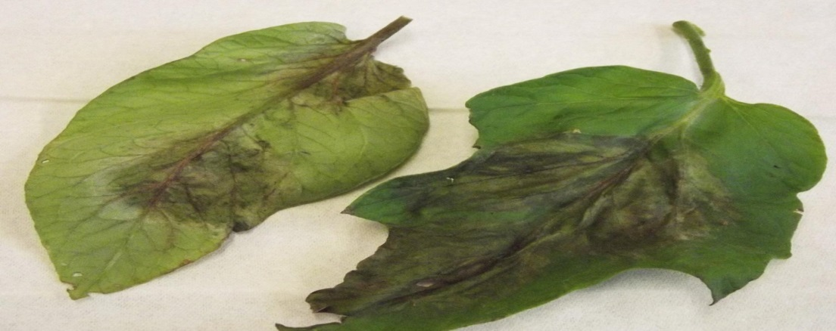](https://s3.amazonaws.com/plantvillage-production-new/images/pics/000/000/629/original/Late_blight_1.jpg?1369844853)

**Fig.64 Late blight symptoms on tomato foliage**

[](https://s3.amazonaws.com/plantvillage-production-new/images/pics/000/003/648/original/5816171413_57a9512966_z.jpg?1415027913)

**Fig.65 Late blight symptoms on tomato leaves**

##### **Symptoms**

Late blight affects all aerial parts of the tomato plant; initial symptoms of the disease appear as water-soaked green to black areas on leaves which rapidly change to brown lesions; fluffy white fungal growth may appear on infected areas and leaf undersides during wet weather; as the disease progresses, foliage becomes becomes shriveled and brown and the entire plant may die; fruit lesions start as irregularly shaped water soaked regions and change to greasy spots; entire fruit may become infected and a white fuzzy growth may appear during wet weather.

##### **Cause**

Oomycete

##### **Comments**

Can devastate tomato plantings.

##### **Management**

Plant resistant varieties; if signs of disease are present or if rainy conditions are likely or if using overhead irrigation appropriate fungicides should be applied.

#### Category : Viral

#### Tomato Yellow Leaf Curl disease Tomato Yellow Leaf Curl Virus (TYLCV) family Geminiviridae, genus Begomovirus

[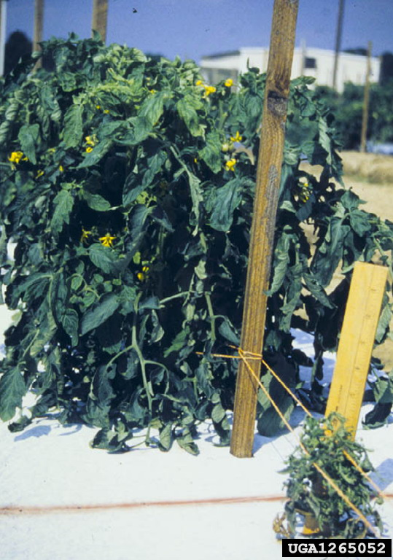](https://s3.amazonaws.com/plantvillage-production-new/images/pics/000/063/706/original/1265052-PPT.jpg?1473970653)

**Fig.66 Early infection of tomato by tomato yellow leaf curl virus often leads to severe stunting of the plant. Infected plant in the foreground with an uninfected one in the back.**

[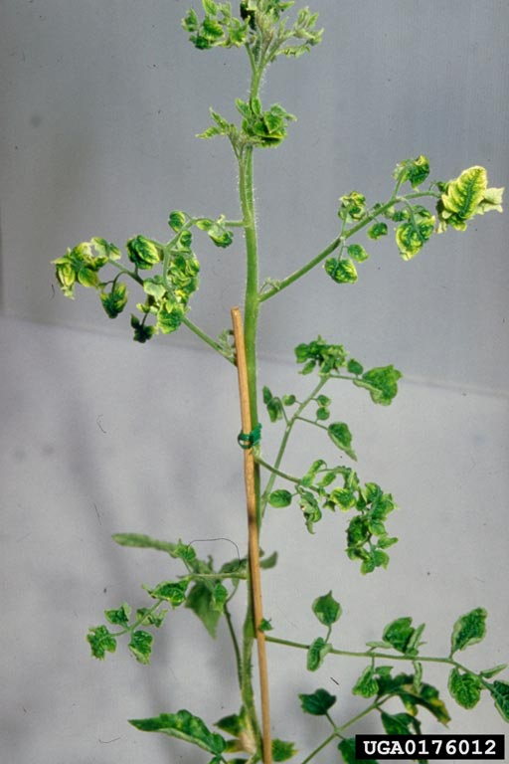](https://s3.amazonaws.com/plantvillage-production-new/images/pics/000/063/695/original/0176012-PPT.jpg?1473967253)

**Fig.67 Tomato Yellow Leaf Curl Virus (Begomovirus TYLCV) infected plant**

[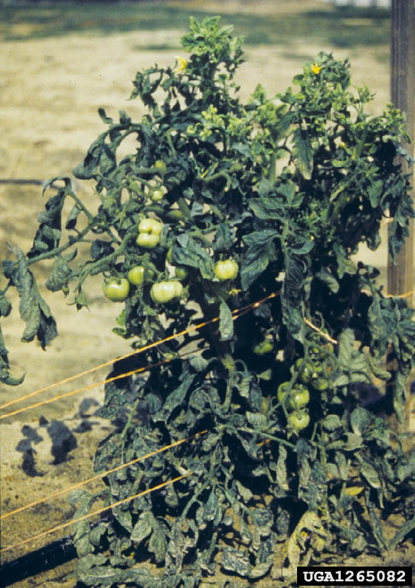](https://s3.amazonaws.com/plantvillage-production-new/images/pics/000/063/700/original/1265082-PPT.jpg?1473969438)

**Fig.68 Infection at later stages of the plant often leads to stunting and malformation of terminals, yellowing of leaf margins and the characteristics upward cupping of leaves ("leaf curl")**

##### **Symptoms**

The infected leaves become reduced in size, curl upward, appear crumpled and show yellowing of veins and leaf margins. The internodes become shorter and whole plant appear stunted and bushy. The whole plant stand erect with only upright growth. The flowers may not develop and drop off.

##### **Cause**

Virus

##### **Comments**

The virus is transmitted by white flies and may cause 100 % yield loss if the plants infect at early stage of crop. The virus also infect other hosts like common bean, ornamental plants and several weed species.

##### **Management**

Grow available resistant varieties. Transplant only disease and whiteflies free seedlings. Remove the infected plants and burn them. Keep the field free from weeds. Use yellow sticky traps to monitor and control whiteflies. If the insect infestation is severe spray suitable insecticides.

**IMPLEMENTATION DETAILS OF THE PROJECT**

**from google.colab import drive**

**drive.mount('/content/drive')**

The above code was to mount data from google drive to **the project’s google colab file do that the project code and its dataset should be in sync with each other.**

**# Import Libraries  
import os  
import glob  
import matplotlib.pyplot as plt  
import numpy as np**

**# Keras API  
import keras  
from keras.models import Sequential  
from keras.layers import Dense,Dropout,Flatten  
from keras.layers import Conv2D,MaxPooling2D,Activation,AveragePooling2D,BatchNormalization  
from keras.preprocessing.image import ImageDataGenerator**

Then the libraries were imported that would be required in the implementation of the project. The **os** library was imported for using a portable way of using operating system and **glob** was imported to retrieve filenames and pathnames and  **matplotlib** is used as it provides object oriented AP, for embedding plots into applications. It also helps in getting a module installed alongside provides state mechanism interface. The **keras** is an artificial neural network library

**# My data is in google drive.CROP DISEASE DETECTION**

**train_dir ="drive/My Drive/CROP DISEASE DETECTION/"**

**test_dir="drive/My Drive/CROP DISEASE DETECTION/**"

In a dataset, a training set is implemented to build up a model while a test set is to validate the model built. The training data is used to make sure the machine recognizes patterns in the data is used to ensure better accuracy and efficiency of the algorithm used to train the machine and the test data is used to see how well the machine can predict new answers based on its training.

**# function to get count of images**

**def get_files(directory):**

**if not os.path.exists(directory):**

**return 0**

**count=0**

**for current_path,dirs,files in os.walk(directory):**

**for dr in dirs:**

**count+= len(glob.glob(os.path.join(current_path,dr+"/*")))**

**return count**

It is a function to get count of images in train and test data. Directory is nothing but an equivalent of folders which is a collect ion of sub-folder or sub-files. In our case the data set is the directory.

**train_samples =get_files(train_dir)**

**num_class=len(glob.glob(train_dir+"/*"))**

**test_samples=get_files(test_dir)**

**print(num_class,"Classes")**

**print(train_samples,"Train images")**

**print(test_samples,"Test images")**

In this case, the get_files function was defined above in the above code and as the argument we have passed train_dir which is a directory of our dataset which was trained through the above code and same was done for the test_dir as well. 15 Classes == 15 types of diseases images are collected. 20719 Train Images and 20719 Test images.

**# Preprocessing data.**

**train_datagen=ImageDataGenerator(rescale=1./255,**

**shear_range=0.2,**

**zoom_range=0.2,**

**validation_split=0.2, # validation split 20%.**

**horizontal_flip=True)**

**test_datagen=ImageDataGenerator(rescale=1./255)**

Rescaling image values between (0 –1) called normalization .Whatever pre-processing one does with the train it should be done to test parallelly. All these parameters are stored in the variable “**train_datagen and test_datagen”.**  Here, the **ImageDataGenerator**  is a function from a library imported above in the project which helps in real data alignment of the images.

And the **horizontal_flip** was made True so the mirror images of the dataset would be allowed.

And the **zoom_range**  would allow to zoom in and out the image by 20%.

**# set height and width and color of input image.**

**img_width,img_height =256,256**

**input_shape=(img_width,img_height,3)**

**batch_size =32**

**train_generator =train_datagen.flow_from_directory(train_dir,**

**target_size=(img_width,img_height),**

**batch_size=batch_size)**

**test_generator=test_datagen.flow_from_directory(test_dir,shuffle=True,**

**target_size=(img_width,img_height),**

**batch_size=batch_size)**

It is used for generating augmented data from train and test directories. Takes the path to a directory, and generates batches of augmented data. Yields batches indefinitely, in an infinite loop .Batch Size refers to the number of training examples utilized in one iteration. Here, 256,256 are the default values since in the pipeline processes batches of images that must all have the same size, this must be provided. It’s a property of each layer and yes it is related to output shape.

**# The name of the 15 diseases.**

**train_generator.class_indices**

It helps in mapping from class name to class names to class as a part of .flow_from_directory() from its ImageDataGenerator class.

**from keras.utils.np_utils import to_categorical**

**model = Sequential()**

**model.add(Conv2D(32, (5, 5),input_shape=input_shape,activation='relu'))**

**model.add(MaxPooling2D(pool_size=(3, 3)))**

**model.add(Conv2D(32, (3, 3),activation='relu'))**

**model.add(MaxPooling2D(pool_size=(2, 2)))**

**model.add(Conv2D(64, (3, 3),activation='relu'))**

**model.add(MaxPooling2D(pool_size=(2, 2)))**

**model.add(Flatten())**

**model.add(Dense(512,activation='relu'))**

**model.add(Dropout(0.25))**

**model.add(Dense(128,activation='relu'))**

**model.add(Dense(num_class,activation='softmax'))**

**model.summary()**

The above block of code is for building CNN model. Each and every layer has a lot of significance. CNN shrinks the parameters and learns features and stores valuable information output shape is decreasing after every layer. 32 Features should be extracted from the input image. Relu is Rectified linear activation to fire up neurons. Flatten layer 4D array to 1D array. Dropout makes some neurons to relax. Softmax activation for probability outputs. In above code it is well shown and covered the important steps to build CNN model that are- Convolution Operation, ReLU Layer (Rectified Linear Unit),Pooling Layer (Max Pooling) ,Flattening, Fully Connected Layer.

**model_layers = [ layer.name for layer in model.layers]**

**print('layer name : ',model_layers)**

This code would help in mentioning visualisation of images after every layer. The layers that are printed would help in writing the further code.

**# Take one image to visualize it's changes after every layer**

**from keras.preprocessing import image**

**import numpy as np**

**img1 = image.load_img('/content/drive/My Drive/CROP DISEASE DETECTION/Potato___healthy/00fc2ee5-729f-4757-8aeb-65c3355874f2___RS_HL 1864.JPG')**

**plt.imshow(img1);**

**#preprocess image**

**img1 = image.load_img('/content/drive/My Drive/CROP DISEASE DETECTION/Potato___healthy/00fc2ee5-729f-4757-8aeb-65c3355874f2___RS_HL 1864.JPG', target_size=(256, 256))**

**img = image.img_to_array(img1)**

**img = img/255**

**img = np.expand_dims(img, axis=0)**

Take a sample image from the train data set and visualize the output after every layer.

Note: Pre-processing is needed for the new sample image. This code would help in mentioning visualisation of images after every layer. The feature maps of a CNN capture the result of applying the filters to an input image. ie at each layer, the feature map is the output of that layer. The reason for visualising a feature map for a specific input image is to try to gain some understanding of what features our CNN detects. In the above code, Numpy is a library for the Python programming language, adding support for large, multi-dimensional arrays and matrices, along with a large collection of high-level mathematical functions to operate on these arrays.

**# Visualizing output after every layer.**

**from keras.models import Model**

**conv2d_3_output = Model(inputs=model.input, outputs=model.get_layer('conv2d_3').output)**

**max_pooling2d_3_output = Model(inputs=model.input,outputs=model.get_layer('max_pooling2d_3').output)**

**conv2d_4_output = Model(inputs=model.input,outputs=model.get_layer('conv2d_4').output)**

**max_pooling2d_4_output = Model(inputs=model.input,outputs=model.get_layer('max_pooling2d_4').output)**

**conv2d_5_output = Model(inputs=model.input,outputs=model.get_layer('conv2d_5').output)**

**max_pooling2d_5_output = Model(inputs=model.input,outputs=model.get_layer('max_pooling2d_5').output)**

**flatten_1_output = Model(inputs=model.input,outputs=model.get_layer('flatten_1').output)**

**conv2d_3_features = conv2d_3_output.predict(img)**

**max_pooling2d_3_features = max_pooling2d_3_output.predict(img)**

**conv2d_4_features = conv2d_4_output.predict(img)**

**max_pooling2d_4_features = max_pooling2d_4_output.predict(img)**

**conv2d_5_features = conv2d_5_output.predict(img)**

**max_pooling2d_5_features = max_pooling2d_5_output.predict(img)**

**flatten_1_features = flatten_1_output.predict(img)**

Above code will help in visualizing output after every layer as mentioned in the code. As conv2d_3, conv2d_4,conv2d_5 and max_pooling2d_3, max_pooling2d_4, max_pooling2d_5 and flatten. Conv2d is to filter input that results in an activation determines number of kernels to convolve with the input volume. It produces 2d activation. Max_pooling2d is an operation for 2d spatial data. It helps in down sampling the input representation by taking the minimum value over the window defined by pool-size.

**import matplotlib.image as mpimg**

**fig=plt.figure(figsize=(14,7))**

**columns = 8**

**rows = 4**

**for i in range(columns*rows):**

**#img = mpimg.imread()**

**fig.add_subplot(rows, columns, i+1)**

**plt.axis('off')**

**plt.title('filter'+str(i))**

**plt.imshow(conv2d_3_features[0, :, :, i], cmap='viridis') # Visualizing in color mode.**

**plt.show()**

Visualizing the output with help of **conv2d_3.**

**import matplotlib.image as mpimg**

**fig=plt.figure(figsize=(14,7))**

**columns = 8**

**rows = 4**

**for i in range(columns*rows):**

**#img = mpimg.imread()**

**fig.add_subplot(rows, columns, i+1)**

**plt.axis('off')**

**plt.title('filter'+str(i))**

**plt.imshow(max_pooling2d_3_features[0, :, :, i], cmap='viridis')**

**plt.show()**

Visualizing the output with help of **map_pooling2d_3.**

**import matplotlib.image as mpimg**

**fig=plt.figure(figsize=(14,7))**

**columns = 8**

**rows = 4**

**for i in range(columns*rows):**

**#img = mpimg.imread()**

**fig.add_subplot(rows, columns, i+1)**

**plt.axis('off')**

**plt.title('filter'+str(i))**

**plt.imshow(conv2d_4_features[0, :, :, i], cmap='viridis')**

**plt.show()**

Visualizing the output with help of **conv2d_4.**

**# we can also visualize in color mode.**

**import matplotlib.image as mpimg**

**fig=plt.figure(figsize=(14,7))**

**columns = 8**

**rows = 4**

**for i in range(columns*rows):**

**#img = mpimg.imread()**

**fig.add_subplot(rows, columns, i+1)**

**plt.axis('off')**

**plt.title('filter'+str(i))**

**plt.imshow(max_pooling2d_4_features[0, :, :, i], cmap='viridis')**

**plt.show()**

Visualizing the output with help of **max_pooling_2d_4.**

**import matplotlib.image as mpimg**

**fig=plt.figure(figsize=(16,16))**

**columns =8**

**rows = 8**

**for i in range(columns*rows):**

**#img = mpimg.imread()**

**fig.add_subplot(rows, columns, i+1)**

**plt.axis('off')**

**plt.title('filter'+str(i))**

**plt.imshow(conv2d_5_features[0, :, :, i], cmap='viridis')**

**plt.show()**

Visualizing the output with help of **conv2d_5.**

**import matplotlib.image as mpimg**

**fig=plt.figure(figsize=(14,14))**

**columns = 8**

**rows = 8**

**for i in range(columns*rows):**

**#img = mpimg.imread()**

**fig.add_subplot(rows, columns, i+1)**

**plt.axis('off')**

**plt.title('filter'+str(i))**

**plt.imshow(max_pooling2d_5_features[0, :, :, i],cmap='viridis')**

**plt.show()**

Visualizing the output with help of **max_pooling2d_5.**

**# validation data.**

**validation_generator = train_datagen.flow_from_directory(**

**train_dir, # same directory as training data**

**target_size=(img_height, img_width),**

**batch_size=batch_size)**

**opt=keras.optimizers.Adam(lr=0.001)**

**model.compile(optimizer=opt,loss='categorical_crossentropy',metrics=['accuracy'])**

**train=model.fit_generator(train_generator,**

**epochs=15,**

**steps_per_epoch=train_generator.samples // batch_size,**

**validation_data=validation_generator,**

**validation_steps= validation_generator.samples// batch_size,verbose=1)**

The above code helps in starting training of CNN with parameters. Adam optimizer is used with learning rate=0.001**.**Loss function **categorical_crossentropy** is used for ourMulti-classclassification problem. Metrics is**“ accuracy”.Fit_generator** is used to train the CNN model. Using the validation data parameter for**fine-tuning the model** and above code is used model building to get trained with parameters.

**accuracy = train.history['accuracy']**

**val_accuracy = train.history['val_accuracy']**

**loss = train.history['loss']**

**val_loss = train.history['val_loss']**

**epochs = range(1, len(accuracy) + 1)**

**#Train and validation accuracy**

**plt.plot(epochs, accuracy, 'b', label='Training accuracy')**

**plt.plot(epochs, val_accuracy, 'r', label='Validation accuracy')**

**plt.title('Training and Validation accurarcy')**

**plt.legend()**

**plt.figure()**

**#Train and validation loss**

**plt.plot(epochs, loss, 'b', label='Training loss')**

**plt.plot(epochs, val_loss, 'r', label='Validation loss')**

**plt.title('Training and Validation loss')**

**plt.legend()**

**plt.show()**

**score,accuracy =model.evaluate(test_generator,verbose=1)**

**print("Test score is {}".format(score))**

**print("Test accuracy is {}".format(accuracy))**

Meaning and the importance of the above code is to determine how accurate the project compilation is. The detailed work for this code has been signified in the results and output section.

**from keras.models import load_model**

**model.save('CROP_PROJECT(re-again).h5')**

**from keras.models import load_model**

**model.save_weights('CROP_PROJECT(re-again)_weights.h5')**

Saving model weights to prevent from re-training of the model.

**classes = train_generator.class_indices**

**classes**

Above code helps to get classes of model trained on.

**# Loading model and predict.**

**from keras.models import load_model**

**model=load_model('CROP_PROJECT(re-again).h5')**

**classes = ['Pepper__bell___Bacterial_spot',**

**'Pepper__bell___healthy',**

**'Potato___Early_blight',**

**'Potato___Late_blight',**

**'Potato___healthy',**

**'Tomato_Bacterial_spot',**

**'Tomato_Early_blight',**

**'Tomato_Late_blight',**

**'Tomato_Leaf_Mold',**

**'Tomato_Septoria_leaf_spot',**

**'Tomato_Spider_mites_Two_spotted_spider_mite',**

**'Tomato__Target_Spot',**

**'Tomato__Tomato_YellowLeaf__Curl_Virus',**

**'Tomato__Tomato_mosaic_virus',**

**'Tomato_healthy']**

Mentioning the name because our output is in numeric format**.**We cast it into strings.This should be preferably done in order in which it was mounted from the drive.

**import numpy as np**

**import matplotlib.pyplot as plt**

**# Pre-Processing test data same as train data.**

**img_width=256**

**img_height=256**

**model.compile(optimizer='adam',loss='categorical_crossentropy',metrics=['accuracy'])**

**from keras.preprocessing import image**

**def prepare(img_path):**

**img = image.load_img(img_path, target_size=(256, 256))**

**x = image.img_to_array(img)**

**x = x/255**

**return np.expand_dims(x, axis=0)**

**result = model.predict_classes([prepare('/content/drive/My Drive/CROP DISEASE DETECTION/Potato___Late_blight/0051e5e8-d1c4-4a84-bf3a-a426cdad6285___RS_LB 4640.JPG')])**

**disease=image.load_img('/content/drive/My Drive/CROP DISEASE DETECTION/Potato___Late_blight/0051e5e8-d1c4-4a84-bf3a-a426cdad6285___RS_LB 4640.JPG')**

**plt.imshow(disease)**

**print (classes[int(result)])**

The above code is the deciding and important implementation for prediction of the disease,it needed to preprocess our image to pass in a model to predict. First, it was resized the image to image(150,150) and convert image to array by this it will add channels as image(150,150,3) RGB. Tensorflow works with batches of images we need to specify image and samples to (1,150,150,3).Predict_classes help to predict the new image belongs to the respective class.

**RESULTS AND OUTPUT**

The proposed CNN project has been executed on GOOGLE COLAB which can be used as an interface to implement Deep leaning models using the CNN algorithm.

|  |  |
| --- | --- |
| **HYPERPARAMETER** | **DESCRIPTION** |
|  |  |
| No. of convolutional layers | 3 |
| No. of max pooling layer | 3 |
| Activation function | Relu |
| No. of epoch | 15 |
| Batch size | 64 |

**Table 2. Hyperparameters for CNN**

|  |  |  |  |
| --- | --- | --- | --- |
|  |  |  |  |

**Image passed in the extracted first extracted second extracted**

**CNN model convolution layer convolution layer third layer**

Moreover, we ran the proposed model for 15 epochs and validation and training accuracy is presented in Illustration 3. For the calculation of loss, the categorical cross entropy method has been applied. The formula for calculating it represented in following equation :

**Loss = - $\sum_{c=1}^{M}{log(po, c)}$**

where M - number of classes, y - binary indicator (0 or 1) if class label c is the correct classification for observation o and predicted probability observation o is of class c.

After analysing the performance of proposed model, we went for the testing. For the testing purpose, total 647 samples have been used and for the various classes testing accuracy is different and it is ranging from 60% to 100% and the average accuracy of the proposed model is **97.58%.**



**Illustration3. Accuracy output of the model**

The accuracy of the proposed model came out to be 97.58%.

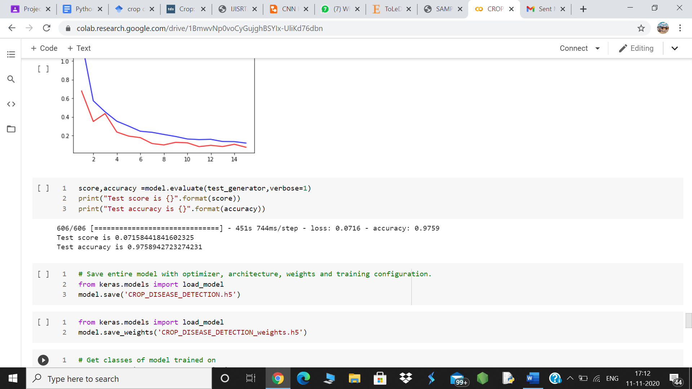

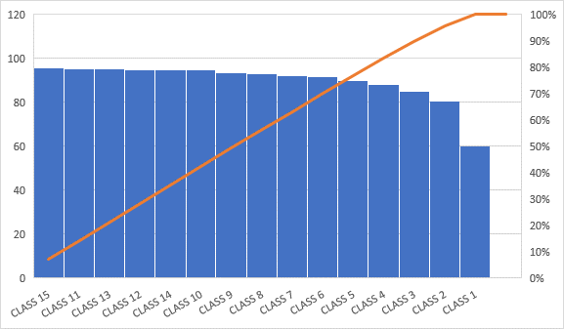

**Illustration4. Analysing Accuracy for each epoch class**

**COMPARISON WITH THE EXISITING MODEL**

There are some existing model that helped in disease detection of various crops of authors such as **Sachin D. Khirade, A.B. Patil,** **Sannakki et al,** **Kutty et al,** **P.R. Rothe, R.V. Kshiragar.** The one which will be compared by the model discussed here would be of **Sannakki et al**.

He had developed their model on the technique of Feed Forward Back Propagation Neural

network ..He has used feed forward back propagation Neural Network based technique for the diagnosis and classification of diseases in grape leaf. Author has used the image s of grape leaf with complex background for the diagnosis as input. Further anisotropic diffusion is used to remove the noise of the image which is further segmented using k-means clustering. Finally results are observed using neural network. Results are experimented on downy mildew and powdery mildew images with simulation in MATLAB. Confusion matrix is considered with the true positive and false positive parameters for the validation of results. The author claimed to have the training accuracy of 100% if used hue feature alone. Here the technique of Feed Forward Back Propagation Neural network has been explained with the backpropagation algorithm is used in the classical feed-forward artificial neural network. It is the technique still used to train large [deep learning](http://machinelearningmastery.com/what-is-deep-learning/) networks. Feed-forward neural networks are inspired by the information processing of one or more neural cells, called a neuron. A neuron accepts input signals via its dendrites, which pass the electrical signal down to the cell body. The axon carries the signal out to synapses, which are the connections of a cell’s axon to other cell’s dendrites .The principle of the backpropagation approach is to model a given function by modifying internal weightings of input signals to produce an expected output signal. The system is trained using a supervised learning method, where the error between the system’s output and a known expected output is presented to the system and used to modify its internal state. Technically, the backpropagation algorithm is a method for training the weights in a multilayer feed-forward neural network. As such, it requires a network structure to be defined of one or more layers where one layer is fully connected to the next layer. A standard network structure is one input layer, one hidden layer, and one output layer. Backpropagation can be used for both classification and regression problems, but we will focus on classification in this existing model.

The model that was discussed in this research paper is based on CNN.CONVULATIONAL NEURAL NETWORKS is well known for its widely used in applications of image and video recognition and also in recommender systems and Natural Language Processing(NLP). However, **convolutional**is**more** efficient because it reduces the number of parameters which makes different from other deep learning models. CNN image classifications takes an input image, process it and classify it under certain categories (Eg., Donkey, Camel, Tiger, Lamb). Computers sees an input image as array of pixels and it depends on the image resolution. Based on the image resolution, it will see h x w x d( h = Height, w = Width, d = Dimension ). Eg. An image of 6 x 6 x 3 array of matrix of RGB (3 refers to RGB values) and an image of 4 x 4 x 1 array of matrix of grayscale image. Technically, deep learning CNN models to train and test, each input image will pass it through a series of convolution layers with filters (Kernals), Pooling, fully connected layers (FC) and apply Softmax function to classify an object with probabilistic values between 0 and 1. The points that has been majorly understood via this project are:

1.Provide input image into convolution layer

2.Choose parameters, apply filters with strides, padding if requires. Perform convolution on the image and apply ReLU activation to the matrix.

3.Perform pooling to reduce dimensionality size

4.Add as many convolutional layers until satisfied

5.Flatten the output and feed into a fully connected layer (FC Layer)

6.Output the class using an activation function (Logistic Regression with cost functions) and classifies images.

**CONCLUSION AND FUTURE WORK**

In the proposed work, we have developed a CNN based model to detect the disease in **TOMATO** and **POTATO** crop. In the proposed CNN based architecture there are 3 convolution and max pooling layers with varying number of filters in each layer. For the experiment purpose, we have taken the tomato and potato leaf data from PlantVillage dataset. In the dataset there are 3 disease classes along with one healthy class for Potato crop and 9 disease classes along with one healthy class for tomato crop. As the images inside class is not balanced, so that data augmentation techniques have been applied to balance the images inside the class. Experimentally, it is observed the testing accuracy of the model is ranging from 60% to 100% for the classes. Moreover, the average testing accuracy of the model is 97.58%. The proposed structure is fit for distinguishing the illness at the earlier stage when it occurs on the leaf. Hereafter saving the hardship and decreasing the reliance on the master to a constrained degree is possible.

As a future work, we are trying to modify the model with a greater number of images with some other crop. Moreover, we are also in process to improve the same model on same dataset as testing accuracy is less. The severity of plant diseases changes with the passage of time, therefore, Deep Learning models should be improved/modified to enable them to detect and classify diseases during their complete cycle of occurrence.

Deep Learning model/architecture should be efficient for many illumination conditions, so the datasets should not only indicate the real environment but also contain images taken in different field scenarios.

A comprehensive study is required to understand the factors affecting the detection of plant diseases, like the classes and size of datasets, learning rate, illumination, and the like.

**REFERENCES**

[1]. https://www.researchgate.net/publication/317858111_A_Survey_on_the_Plant_Leaf_Disease_Detection_Techniques

[2].

https://machinelearningmastery.com/implement-backpropagation-algorithm-scratch-python/

[3].

https://towardsdatascience.com/crop-plant-disease-identification-using-mobile-app-aef821d1a9bc

[4].

https://medium.com/@RaghavPrabhu/understanding-of-convolutional-neural-network-cnn-deep-learning-99760835f148

[5].

https://www.frontiersin.org/articles/10.3389/fpls.2016.01419/full

[6].

https://www.hindawi.com/journals/ddns/2020/2479172/

[7]. P. Krishna Chaitanya , K. Yasudha, “Image based plant disease detection using convolution neural network algorithm”, International Journal of Innovative Science and Research Technology ISSN No:-2456-2165, May 2020 .

[8]. Mohit Agarwala , Abhishek Singhb, Siddhartha Arjariac , Amit Sinhad, Suneet Guptaa, “ToLed : Tomato Leaf Disease Detection using Convolution Neural Network” , International Conference on Computational Intelligence and Data Science (ICCIDS 2019).

[9]. Pico, B., D `ez, M.J., Nuez, F., 1996. Viral diseases causing the greatest economic losses to the tomato crop. ii. the tomato yellow leaf curl virus—a review. Scientia Horticultural 67, 151–196.

[10]. Dataset Link

https://github.com/salathegroup/plantvillage_deeplearning_paper_dataset.